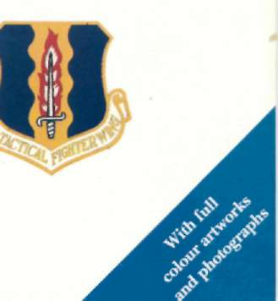
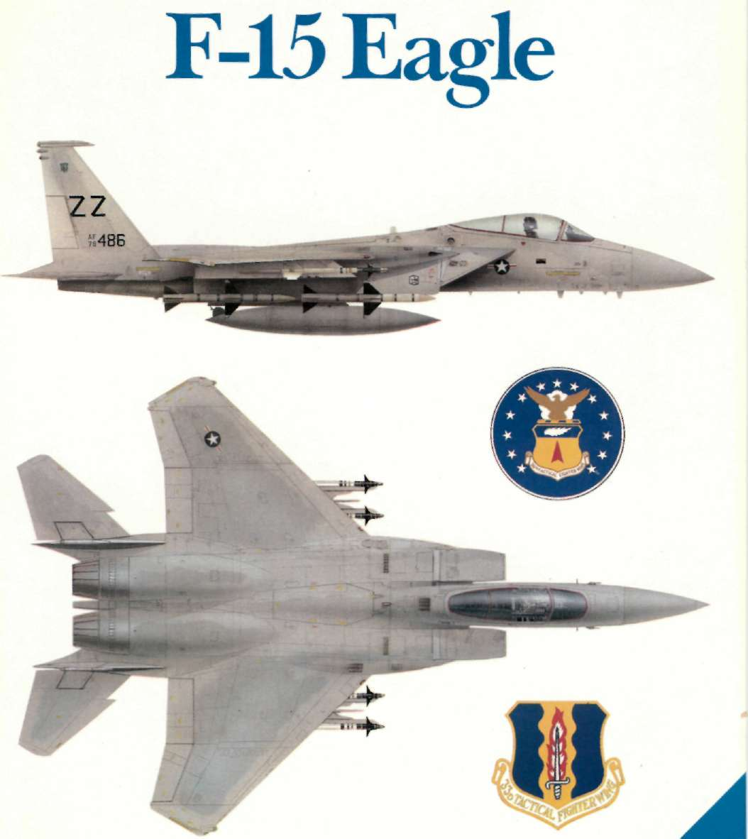
1 OSPREY • COMBAT AIRCRAFT SERIES
MIKE SPICK
COMBAT AIRCRAFT SERIES
F-15 Eagle
MIKE SPICK
OSPREY PUBLISHING LONDON
'
Published in 1986 by
Osprey Publishing Ltd
Member Company of the George Philip Group
12-14 Pong Acre, London WC2E 9LP
This book is copyrighted under the Berne Convention.
All rights reserved. Apart from any fair dealing for the purpose of private study, research, criticism or review, as permitted under the Copyright Act, 1950, no part of this publication may be reproduced, stored in a The Author
retrieval system, or transmitted in any form or by any M I K E SPICK has had a lifelong interest in military means, electronic, electrical, chemical, mechanical, aviation, and is author of several technical books and optical, photocopying, recording or otherwise, without articles in aviation magazines covering various aspects the prior permission of copyright owner. Enquiries of the subject. One of his leisure pursuits, wargaming, should be addressed to the Publishers.
led him to a close stludy ol air warfare, combat aircraft and the evolution of air combat tactics, on all of which
©Copyright 1986 Bedford Editions Ltd.
he has written extensively.
British Library Cataloguing in Publication Data
Contents
Spick, Mike
Chapter 1:

F-15 Eagle. —(Osprey combat aircraft)
The Eagle Concept
3
1. Eagle (Jet fighter plane) — History
Chapter 2:

I. Title
The Baseline Aircraft
16
623.74'64 UG1242.F5
Chapter 3:

Missions and Weaponry

30
ISBN 0-85045-706-8
Chapter 4:

Improving the Breed

36
Typeset by Flair plan Photo-typesetting Ltd.
Chapter 5:

Printed by Proost International Book Production,
Eagle in Service
43
Turnhout, Belgium.
Colour: profiles page 27, © Pilot Press Ltd;
remainder Stephen Seymour, Mike Keep, Brian Knight
© B e d f o r d Editions Ltd.
Cutaway drawing: Michael Badrocke
Diagrams: T I G A
Photographs: Supplied by McDonnell Douglas
(Corporation, and the US Department of Defense.
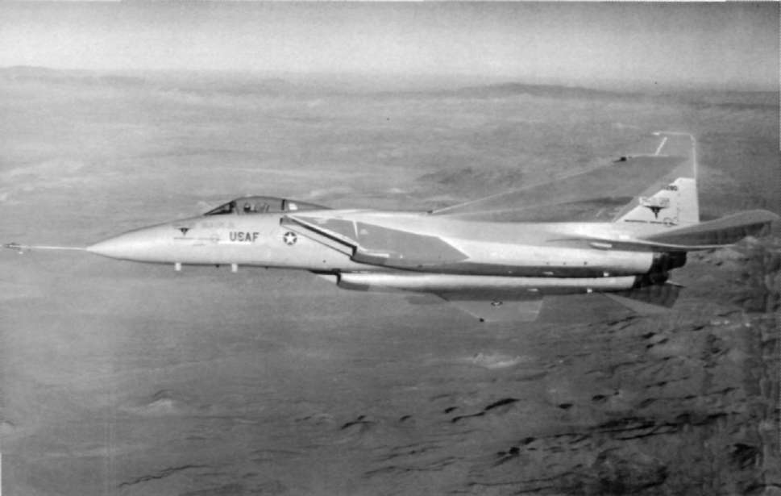
1
The Eagle Concept
THE McDONNELL Douglas F-15 Eagle is Originally ordered as a fleet fighter for the US
widely considered to be the world's greatest
Navy, it had been developed f r o m an "all-can-do"
lighter, able to outlly. outmanoeuvre and
proposal by McDonnell, a philosophy that served it outshoot anything else in the sky. This happy state of well when it was adopted by the USAF as a tactical affairs did not come about by chance for fighter
fighter. The Phantom is a weapon system rather than design is basically a combination of three factors. a true fighter and, in Vietnam, was theoretically able These are, firstly, the nature of the threat, either real to destroy opposing N V A F MiG-17s, MiG-19s and or predicted; secondly, available technology; and, Mi(l-21s before they ever got within range. In prac-thirdly, available funding, which is, in turn, affected tice, it didn't work out like that, great difficulty being by the minimum force size considered necessarv.
experienced in identification at beyond visual range In the second half of the 1960s, the threat con-
(BVR) and severe restrictions were thus imposed on sisted of large numbers of cheap, lightweight and the use of BVR weapons, which effectively put the highly manoeuvrable Soviet-designed fighters. In aircraft at a disadvantage.
distinct contrast, American fighters tended to be very capable, very large and very expensive, the F-4 Below: The high-visibility red paint applied to areas of the wings, tail and air intakes is apparent in this in-flight study of Phantom II being typical.
the first F-15A Eagle prototype.
3
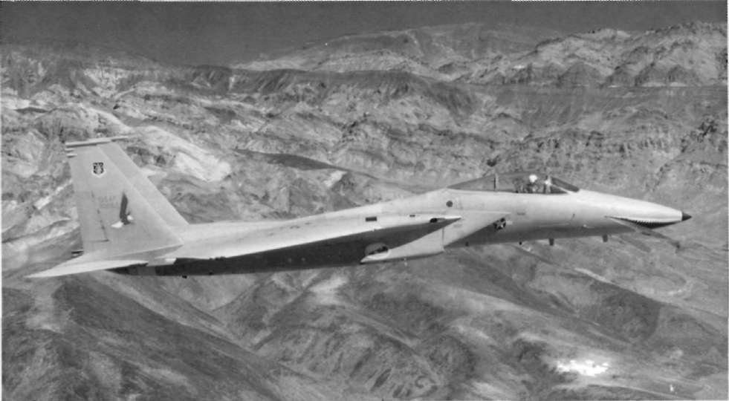
Missile failures also impaired 1-1 capability, while Foxbat was at first perceived to have greater speed, the faet that it was not designed for close combat acceleration and range than it in fact possessed, to be meant that, for a time, it put up a very poor showing fully-stressed for fighter-type manoeuvring and to in the dogfight arena. Superior tactics, better training have an empty weight calculated to be some 25 per and improved weapons went some way towards cent less than it actually was. Foxbat was mainly an redressing the balance but the 7:1 kill ratio achieved exercise in pushing the limits of Soviet technical by the F-86 Sabre over the MiG-15 in Korea never
expertise as far as they would go and had actualh remotely looked like being approached. Thus, by the been designed not as an air superiority fighter but as mid-1960s, it was evident that something better was a pure interceptor.
needed to achieve air superiority, especially if hostilities commenced in Europe, where N A T O fighters Erroneous reports
would be heavily outnumbered by Warsaw Pact
aircraft, notably the MiG-21.
Thus, in close combat, the Phantom could have
run rings round it but there was no means of
An aerial "bogeyman"
knowing that at the time and the general confusion was compounded by reports emanating from the
Then, in July 1967, the Soviet Union revealed to
Soviet Union which referred to massive production an astonished Western world what was to become for of the MiG-23, as Foxbat was first thought to be
many years an aerial "bogeyman". A massive twin-designated. It was only much later that this point was engined, twin-finned fighter, the MiG-25 Foxbat cleared up, the MiG-23 being positively identified as showed its mettle just three months later when it a new variable geometry fighter that had made its broke the 500km and 1,000km closed-circuit speed
public debut at the same time.
records previously held by the Lockheed YF-12A, an Fmergence of Foxbat had a considerable impact
event which prompted many commentators to reach
not only on the F-15 but also on its counterpart and the conclusion that Foxbat must be better all round, sometime rival, the US Navy's F-14 Tomcat. The US
an opinion which appeared to be confirmed by the
erudite calculations of certain Western aerospace Below: Sporting a fearsome shark's mouth on the nose and with an eagle motif on the vertical tail, F-15A 71-0282 was the third of analysts.
ten prototype single-seaters.
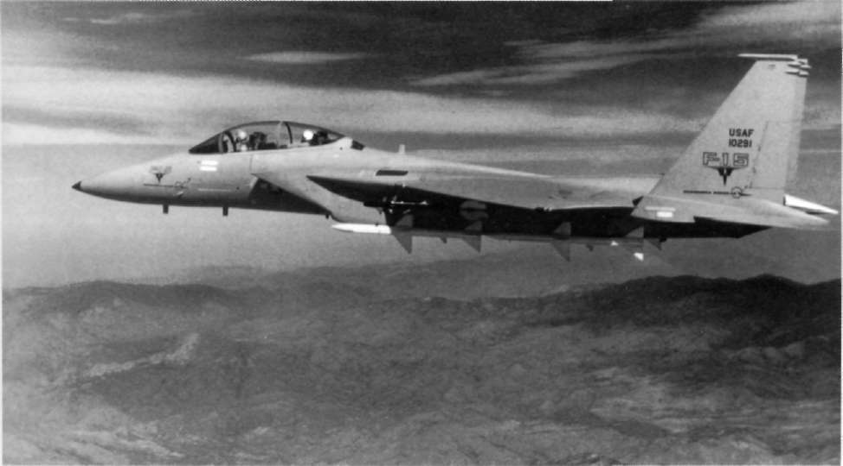
Navy's answer was the long-range Phoenix air-to-air A I M - 7 Sparrow radar-homing missiles, four A I M - 9
missile, whereas the A i r Force was anxious to acquire Sidewinder infra-red homing missiles and, for "close a fighter with a fantastic rate of climb that could encounters", a 25mm cannon firing caseless reach Foxbat's operational altitude quickly from a ammunition.
standing start, detect it at long range and attack it head-on. Provided that adequate early warning was Uncertainty over requirements
available, rate of climb sufficient and ceiling high enough, the new fighter would not need to match the American fighter development had been on a "back Foxbat's tremendous maximum speed. In addition,
burner" since the service entry of the Phantom, with of course, the threat posed by light, agile fighters nobody apparently able to decide what was needed to could not be ignored, and any new fighter had to be replace it. The USAF had issued a Request For
able to oppose these effectively despite being heavily Proposals (RFP) in December 1965 for a tactical
outnumbered.
support aircraft, which was not pursued. Then, in If this could also be built in to the equation,
August 1967, rather coincidentally just one month dogfighting with the Foxbat would pose no insoluble after the unveiling of the Foxbat at Domodedovo, a problems as turning capability is essentially a func-second RFP was issued, this time for a fighter. This tion of speed. Thus, the new lighter would always be resulted in a concept formulation study being
capable of outmanoeuvring the Foxbat by virtue of awarded to M C A I R and General Dynamics. This was being slower, while, if the Russian fighter slowed duly completed, and. in September 1968, a further down for a turning engagement, it would obviouslv RFP was issued to industry for the FX (fighter
be outclassed by a fighter that could outmanoeuvre a experimental), soon to be designated F-15.
MiG-21. The best solution to the greater weight of At first, a maximum speed of Mach 3 was re-numbers was felt to lie in a marriage of high-
quested, but. since this requirement was in direct technology electronics lor detection and weapons conflict with manoeuvrability needs, it was later guidance with an armoury that comprised four dropped. The original eight bidders were short-listed to three and final submissions were made in Below: The two-seat Eagle was originally designated the TF-June 1969. In December of that year, M C A I R was 15A, this being subsequently changed to F-15B. This picture portrays the second of the two prototypes.
declared the winner, the proposal being for a large.
5
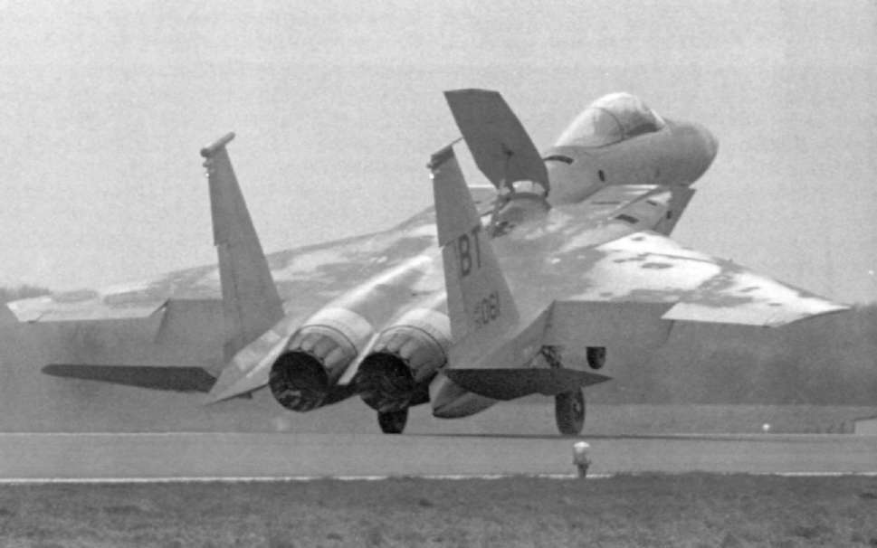
twin-engined and twin-finned single-seater. A perance. T h e second reason was that the thrust/weight sonal reaction on seeing the first pictures to be ratio for the new fighter was planned to be higher released was that it was too close to the Foxbat in than anything previously flown, apart from a few general appearance to be entirely comfortable. experimental rocket-powered types.
although a complete departure from the Soviet
design was evident in the bubble canopy. In fact, the A new engine for the FX
vague similarity is coincidental, M C A I R and the Mikovan Bureau having arrived at similar solutions The FX specification was intended to produce a for rather different problems.
twin-engined fighter and the development of adv-
Dimensionally, the F-15 is BIG, being rather larger anced augmented turbofans had been initiated for
than the Phantom, although weighing quite a bit less.
the project as early as 1968. Competition between There were two main reasons why it could hardly
Pratt & Whitney and General Electric resulted in the have been smaller. One was the weapons load re-selection of P & W's F100 turbofan in 1970. To attain quired by the air-to-air role. Four Sparrows and four the high thrust needed, turbine inlet temperatures of Sidewinders are not particularly heavy, their total the order of l,400degC were required, pushing the weight being about 1
technology of the time very hard indeed.
1/4 tonnes, roughly 10 per cent
of the empty weight of the F-15. They do, however, The F100 engine is large and the side-by-side
take up a lot of space; the Sparrow is 12ft (3.66m) mounting, with separation determined by the de-long and has a span of 40in (102cm) over the control mands of the engine systems and accessories and also surfaces. Sidewinder is smaller, being 9.35ft (2.85m) the main structural frames, dictated the width of the long and with a 2.07ft (63cm) span. If the size of the fuselage. Actually, engine separation is very neces-aircraft had been reduced, it would have been dif-sary for it aids cooling and reduces the chance of ficult to find somewhere to hang them, while their percentage proportionate weight would have in-Below: The large wing, twin fins, fuselage air brake and generous flap area of the F-15 are displayed to advantage in this creased, with a consequent reduction in perform-view of a 36th TFW Eagle touching down.
6
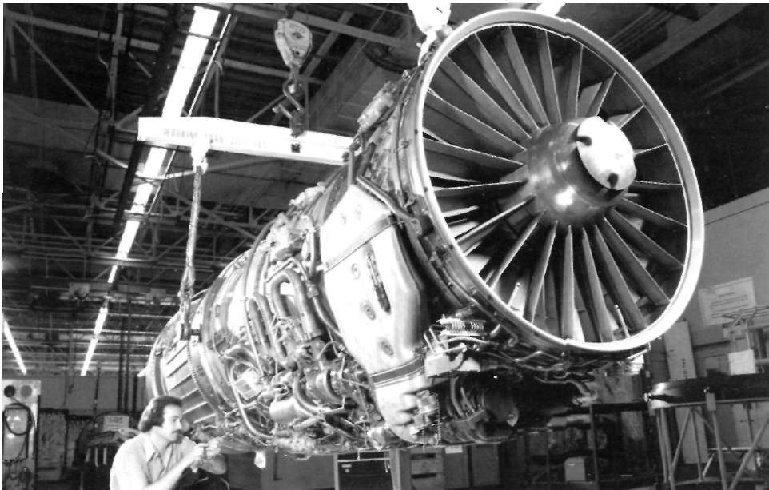
both engines being taken out by a single hit in needed to have the engines m o u n t e d near to the combat. F u r t h e r m o r e , in the event of a catastrophic centre of gravity, but advances in aerodynamics a n d failure in one e n g i n e — s u c h as t u r b i n e failure or the flight control systems enabled t h e m to be located at shedding of compressor b l a d e s — t h e r e is less likeli-the rear of t h e F-15. The nozzles are of a convergent-hood of d a m a g e being caused to the good engine.
divergent (con-di) type a n d are s u r r o u n d e d by a Where side inlets are used, it also keeps the intake series of moveable flaps, often called "turkey feath-duct as straight as possible a n d thus minimises How ers", which r e d u c e base d r a g .
distortion. T h i s is important, when, as in the F-15, the inlet duct is quite long. T h e duet itself is normally Unusual air intakes
painted white, for two reasons. In air combat, it is desirable to remain unseen a n d a white duet mini-At the o t h e r e n d , the intakes are of a sharply-mises the "black hole" effect often presented by a raked two-dimensional type, with two moveable
lighter attacking from h e a d - o n . Secondly, the white r a m p s to control the air influx a n d provide a shock-paint should reveal the presence of foreign objects or wave at supersonic speeds so as to slow down air
provide evidence of foreign object d a m a g e (FOD), being ingested. T h e y have o n e very interesting fea-either in the form of blood a n d feathers, or as ture, the front of the intakes employing variable scratches.
geometry so that they can " n o d " to angles of up to To return to the engines, these are located at t h e 1 1 d e g below or 4leg above the horizontal. Control-rear of the fuselage. T h e previously widely used led by the air data c o m p u t e r , which also operates the mid-position caused problems in locating the tail moveable r a m p s as a function of d y n a m i c pressure, surfaces which is why t h e rear e n d of the P h a n t o m they pivot about their lower e d g e to adjust the angle looks so peculiar. Previous generations of fighters of airflow entering the intakes.
In m a n o e u v r i n g combat, they assist in keeping the Below: At the heart of the Eagle's superlative performance lies intakes pointing into the local airflow at high angles the Pratt & Whitney F100-PW-I00 turbofan engine, two examples of which power every F-15 built.
of attack, s m o o t h i n g it out a n d helping to prevent 7
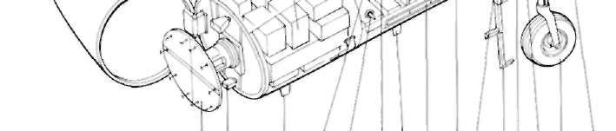
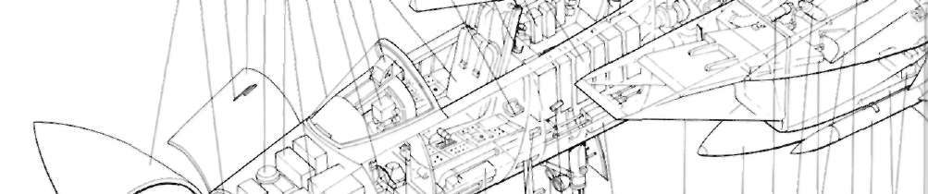
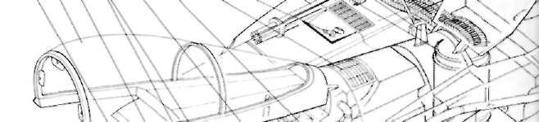
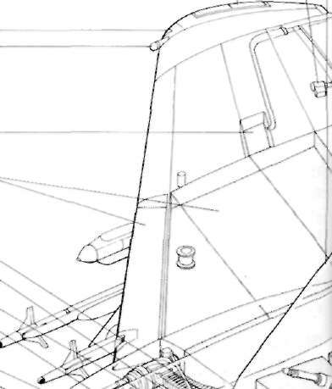

MCDONNELL DOUGLAS F-15 EAGLE KEY
69. Fuel vent compartment.
80. Main undercarriage
70. Outboard wing stores
hydraulic jack.
1. R a d o m e .
3 9 . P r a t t & W h i t n e y F 1 0 0 - P W -
pylon.
81. Missile launch rail.
2. R a d a r Hood h o r n .
1 0 0 a f t e r b u r n i n g t u r b o f a n
71. Westinghouse ECM
82. Anti-collision light.
3. Pitot h e a d , port a n d
e n g i n e s .
equipment pod.
83. AIM-9I. Sidewinder
s t a r b o a r d .
4 0 . S t a r b o a r d all-moving
72. Port wing integral fuel
air-to-air missile (4).
4. Avionics bay d o o r .
tailplane.
tanks.
84. In-flight refuelling
5. A D F sense aerial.
4 1 . S t a r b o a r d f i n .
73. Hydraulic accumulators.
receptacle.
6. F o r w a r d avionics e q u i p m e n t 4 2 . F o r w a r d facing ECM
74. Engine driven accessory
85. Pefuelling receptacle door
bay.
aerial.
gearbox.
hydraulic jack.
7. Frameless w i n d s c r e e n p a n e l .
4 3 . Aft lacing ECM a n t e n n a .
75. Inboard wing stores pylon.
86. Fire control system missile
8. R u d d e r pedals.
4 4 . Anti-collision light.
76. Jet fuel starter.
launch units.
9. I n s t r u m e n t display.
4 5 . S t a r b o a r d r u d d e r .
77. Main undercarriage pivot
10. H e a d - u p display.
4 6 . E C M a n t e n n a .
bearing.
11. McDonnell Douglas A C E S
4 7 . A f t e r b u r n e r nozzle control
78. Forward-retracting main
28 29 30
II ejection seal.
jacks.
undercarriage.
12. H a n d h o l d / s t e p .
4 8 . l o r e a n d aft r a d a r w a r n i n g 79. Hydraulic system reservoir.
13. Cockpil c a n o p y cover.
p o d .
14. C a n o p y jettison strut.
4 9 . ECM a n t e n n a .
15. Tactical elect ionic w a r f a r e
5 0 . Tail navigation light.
27
system ( T E W S ) e q u i p m e n t .
5 1 . Port f i n .
26
16. C a n o p y a c t u a t o r .
5 2 . Port r u d d e r .
17. Cockpit an c o n d i t i o n i n g
5 3 . R u d d e r hydraulically
system.
o p e r a t e d r o t a r y a c t u a t o r .
18. Heat e x c h a n g e r a i r
5 4 . Variable a r e a a f t e r b u r n e r
e x h a u s t .
nozzle.
19. I n t a k e spill d o o r a n d
5 5 . l a i l p l a n c h y d r a u l i c
25
h y d r a u l i c jack.
a c t u a t o r .
2 0 . M61 A-l 2 0 m m six-barrel
5 6 . l a i l p l a n c pivot b e a r i n g .
rotary c a n n o n .
5 7 . Fort all-moving tailplane.
2 1 . A m m u n i t i o n d r u m .
5 8 . F o r m a t i o n lighting s n i p .
24
2 2 . U p p e r U H F / I F F aerial.
5 9 . E m e r g e n c y a r r e s t e r h o o k .
2 3 . A m m u n i t i o n feed c h u t e .
60. P r i m a r y heat e x c h a n g e r ,
24. S t a r b o a r d wing integral
port a n d s t a r b o a r d .
fuel tanks.
6 1 . Port a i l e r o n .
25. Fuel vent c o m p a r t m e n t .
6 2 . Fuel jettison.
23
2 6 . ECM a n t e n n a .
6 3 . Aileron h y d r a u l i c a c t u a t o r .
27. S t a r b o a r d navigation light.
6 4 . F o r m a t i o n light.
22
2 8 . F o r m a t i o n light.
6 5 . Port navigation light.
2 9 . Aileron hydraulic a c t u a t o r .
66. ECM a n t e n n a .
21
3 0 . A i r b r a k e .
6 7 . Fuel jettison valve.
20
3 1 . A i r b r a k e hydraulic jack.
6 8 . Flap h y d r a u l i c a c t u a t o r .
3 2 . Flap hydraulic a c t u a t o r .
3 3 . S t a r b o a r d aileron.
19
34. Hydraulically driven
12 13 14 15 16 17 18
e m e r g e n c y g e n e r a t o r .
35. High b a n d t u n e r .
36. I n t a k e duct bleed air
supply to heat e x c h a n g e r ,
37. Plain flap.
38. E n g i n e bleed a i r d u c t i n g .
1 2 3 4 5 6 7 8 9 10 11
93 92 91 90 89 88 87 86 85
108 107 106 105 104 103 102 101 100 99 98 97 96 95 94
8

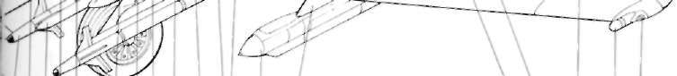
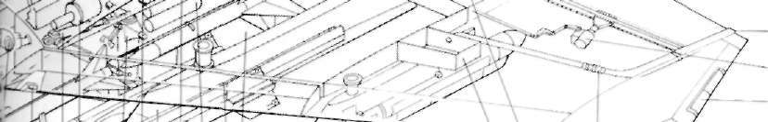
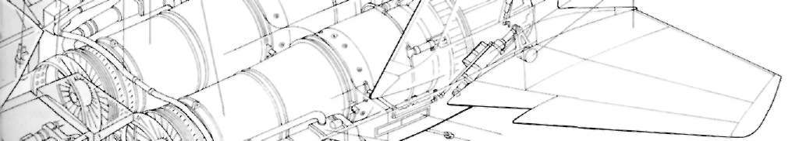
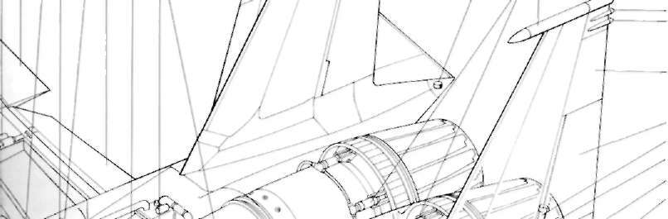
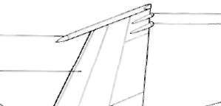
87. AIM-7F Sparrow air-to-air
92. Centreline external fuel 94. Flight control 96. Canopy emergency release.
missile.
tank. augmentation system
97. Landing and taxying
88. Air system ducting.
93. Variable incidence equipment.
lamps.
89. Variable area intake ramp
"nodding" air intake. 95. Forward-retracting 98. Retractable boarding
doors.
nosewheel.
ladder.
90. Ramp hydraulic actuator.
99. Boarding step.
91. Intake incidence control
100. Underfloor avionics
jack.
43
equipment bay.
44
101. Formation lighting strip.
42
102. TACAN aerial.
103. Control column linkage.
104. Incidence probe.
41
105. Liquid oxygen converter.
106. Lower U H F aerial.
107. ILS glideslope aerial.
32 33 34 35 36 37 38 39
40
45
108. APG-63 pulse doppler
46
47 48
antenna.
49
50
51
52
53
54
55
56
57
58
59
60
61
62
S3
64
69 68 67 66 65
83 82 81 80 79 78 77 76 75 74 73 72
71 70
9
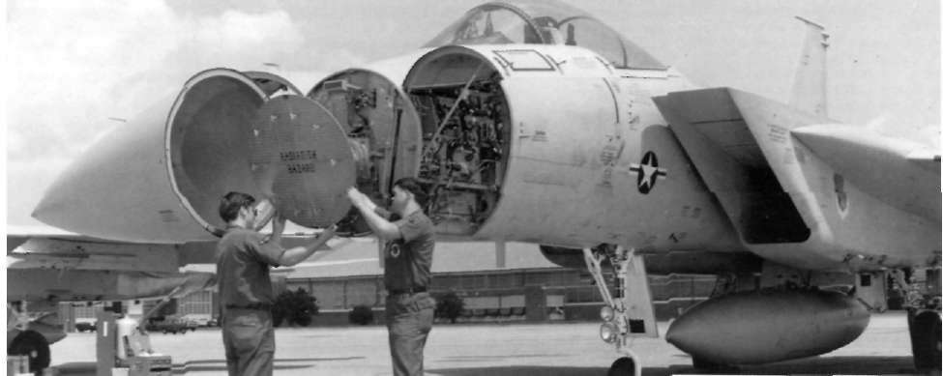
compressor stalls. The previous P&W military Above: The F-15's novel variable geometry "nodding" air intakes are clearly visible in this close-up view of the nose engine—the TF30, which is used by the F-l5 and section, as is the Hughes AN/APG-63 radar antenna.
the F-l4—had been notoriously sensitive to dis-
turbed airflow and M C A I R was obviously anxious to the larger proportion of lift is generated from the minimise the risk of a repeal performance. On the upper surfaces, this plateau-like area contributing ground, they automatically nod downwards when greatly to the overall lift of the F-15. Located a short the engines are started, ready for the rotation phase distance behind the cockpit canopy is the single-piece of take-off.
speed brake, this being actuated by a hydraulic ram.
It is often not appreciated that the variable intakes It is, quite simply, an awful place to put it. since, have a further function for they give extra man-when in use, it obscures much of the view astern and, oeuvre control rather in the manner of canard although mainly used on final approach, there is no foreplanes. Thus, at supersonic speeds, they help to law that states that F-15s must not be attacked in the
"unload" the horizontal tailplane, which has allowed landing pattern. However, in designing any fighter, space is always at a premium and it appears that this this to be made smaller and lighter than would location was an unavoidable, albeit undesirable, com-otherwise have been possible. In this respect, they are promise.
superior to the snakes which feature so prominently on both the F-16 and F-l8 and whose basic function The size of front fuselage is dictated by two lac tors.
is to create a vortex across the wing.
Firstly, there is the radar antenna, which in turn is sized by the performance requirement. Secondly, it is Appearances are deceptive
desirable to achieve the best possible fineness ratio so as to minimise transonic drag. The radar selected was The undercarriage looks inadequate for the job, the Hughes APG-63, which has an antenna only given the sheer bulk of the F-15. The nose gear is slightlv smaller than that of the F-14. A direct
long and stalky and looks flimsy, while the main consequence of this is that the cockpit is distinctly gears are. by contrast, short and have a relatively roomy.
narrow track. This feature was to contribute to
One of the most distinctive features of the aircraft problems at the flight test phase. A tail hook is fitted is tfie canopy, which sits high on the forward nacelle, flush between the engines. On early aircraft, the just in front of the intakes, and has a minimum of hook was covered with doors, although this no structural members. The cockpit sills are cut clown longer appears to be the case.
slightly and the pilot, seated high up on his ejection The upper surface of the rear and mid-fuselage scat, has an excellent Held of view through 360
sections is almost flat, curving slightly around the degrees (except when using the speed brake) and engine bays as it approaches the rear. In flight, by far down past the sides of the nose. T h e windshield is a 10
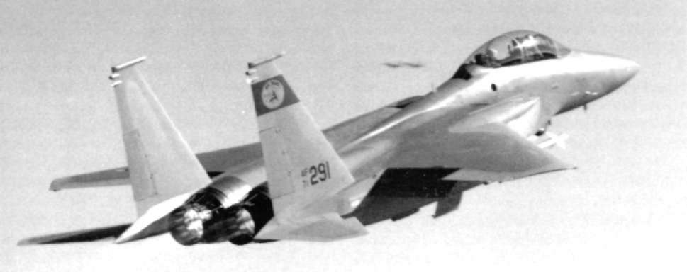
Above: Getting airborne in a hurry, MCAIR's two-seat The structural elements of the wings consists of
demonstrator, 71-0291, clearly reveals the wide-set vertical tails and exhaust nozzles of the Eagle.
three main spars, which are of titanium in the
inboard section. In the event of battle damage, this completely curving surface and is in no place optical-gives a measure of redundancy, as the aircraft will ly flat. The canopy is hinged at the rear and is fly, although not fight, with any one of them severed.
operated by a hydraulic jack.
One of the few programme failures was the 25mm
caseless ammunition cannon. Consequently, the very Low wing loading
reliable Vulcan M61 20mm cannon is fitted instead.
complete with 940 rounds of ammunition. It is
In its most basic terms, manoeuvrability in a located in the starboard wing root, with the muzzle fighter is a combination of two (actors. The first is positioned well behind the intake to prevent inges-thrust/weight ratio, in this case conferred by two big tion of exhaust gas.
turbofans. The second is wing loading, which needs With the engines occupying virtually the entire
to be low. The wing design chosen for the F-15 is rear fuselage, the tail surfaces are mounted on short simplicity itself, although, of necessity, it needed to be booms outside, and extending astern of, the nozzles.
large in order to spread the loading. It is located in The horizontal stabilizers are set low. away from the optimum, shoulder position, which is both easy turbulent wing wake, with a sweep angle matching
from a structural point of view and also keeps its that of the wing and twin fins are set on top of the members out of the way of avionics and engine bavs, booms.
thus allowing easy access to these areas.
The wing planform is a cropped delta with slight
Twin fins for good stability
sweep on the outboard trailing edge.
The leading edge is plain, with no high lift devices, There are various reasons for having twin fins,
featuring sharp taper on the leading edge and although they do as a rule add weight and complex-conical camber outboard. Wing sweep is 45deg, the ity. At very high Mach numbers for instance, lateral aspect ratio is 3, anhedral is just 1deg, and incidence instability becomes an increasing problem and more is zero. The trailing edge contains simple flaps keel area is needed to counteract it. The fin can be inboard and. rather surprisingly, conventional ailer-extended in length, at the cost of decreasing its ons outboard. Thickness/chord ratio varies from 5.9
aspect ratio and, with it, much of its effectiveness.
to 3 per cent. The wing area is 608sq ft (56.5sq m), Fins are simply vertical wings and aspect ratio there-which at fighting weight with 50 per cent fuel, gives a fore has a great deal to do with how well they
wing loading of 591b/sq ft (288kg/sq m), by present perform.
day standards almost o f f the bottom of the charts.
With a fighter, high angles of attack may blanket 11
the fin and rudder and render them ineffective. This above and forward of the horizontal stabilizer. A is less likely to happen with twin fins positioned on warlike appearance was only evident in the three
the outside of the fuselage. Alternatives are a very tall white-painted dummy Sparrows on the fuselage sta-f i n , as with Tornado, or a folding ventral fin as with tions, these being supplemented by an Eros collision the MiG-23. Bearing in mind the wide rear fuselage avoidance pod in white with a red nose on the front of the F-15, there was probably not a lot of choice.
left station.
The fins, with a single rudder, are square tipped and The roll-out ceremony complete, high visibility
also serve as a housing for various aerials.
orange markings were applied to the pitot, front
This then was pretty much a description of the
sides of intakes, leading edges and outboard sections prototype F-15 (71-0280) as presented to the public of wings, fins, and stabilizers. It was then uncere-on roll-out day, June 26, 1972. As we have now seen, moniously dismantled and made its first flight in the there was a reason for everything in the basic design hold of a C-5A Galaxy to Fdwards AFB in California, and the apparent resemblance to the MiG-25 was where it was reassembled. Minus the dummy Spar-purely coincidental. In terms of mission capability, rows, it took to the air under its own power on 27
the two fighters were poles apart, although this was July with MCAIR's chief test pilot, Irving Burrows, at not known at the time.
the controls.
Its function was to explore the flight envelope and Initial contract requirements
handling qualities and. later on. the carriage of external stores. It was followed into the air some two The original F-15 contract called for 20 aircraft. months later by the F100 engine test vehicle, 71-These were split into two batches, the first compris-0281, and the remaining prototypes followed in
ing ten single-seat F-15As—numbered 71-0280 to rapid succession, the twelfth (71-0289), assigned to 71-0289—and two twin-seat TF-15A trainers num-tactical electronic warfare, radar and electronics eva-bered 71-0290 and 71-0291. These were for Categ-
luation making its first flight on January 16, 1974.
ory I testing, contractor development, testing and The TF-15As, later to be redesignated F-l5Bs. had evaluation. The second batch consisted of eight flown out of numerical sequence, being the eighth F-15As—72-0113 to 72-0120—and, in contrast to and tenth aircraft to take to the air.
the first batch, which could be considered as prototypes, these were viewed as Full Scale Development External and internal changes
(FSD) aircraft for Categories II and I I I testing. Cat II objectives concerned A i r Force development, test Certain troubles experienced in the early stages ol and evaluation, while Cat I I I involved follow-on the flight test programme eventually led to external operational testing and evaluation, the FSD aircraft changes, while others needed modifications that took being as closely matched to the production article as place "under the skin". For example, buffet encoun-possible.
tered in certain flight conditions appears to have The first prototype duly made its debut at the been due to span-wise airflow. An early attempt at a McDonnell Douglas facility at Lambert St. Louis " f i x " tested on 71-0280 was wing fences. These International Airport and, unlike many other first proved unsatisfactory and the remedy adopted was
prototypes, it had been given virtually no cosmetic: to delete that portion of the wing causing the trouble.
treatment, a small McDonnell Douglas company logo About 4sq ft (0.37sq m) was removed f r o m the wing being carried on the nose with F-15 logos displayed tip. extending back and in f r o m the leading edge to both there and on the fins, in black.
give the distinctive cropped appearance which is still The forward main gear doors were open while it
a feature of the aircraft. At a later date, formation was on the ground—a feature of all early F-15s— lights were added to this raked end.
and it was equipped with an instrumented pilot
The tail was discovered to be prone to flutter in boom on the nose. The only break in the overall some flight regimes and this was cured by extending colour scheme was the pale yellow, low-voltage the mean aerodynamic chord outboard, to give a formation lighting strips set low on the front fuselage snagged leading edge.
beneath the cockpit and on the rear fuselage just Both the buffet and the flutter problems were
12
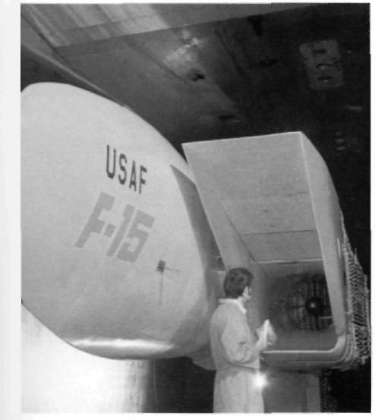
discovered and solved at such an early stage in the coupled with the light wing loading caused a distinct programme that the "fixes" were put in hand on the tendency to 'weathercock", or turn into wind. This production line, prototype No. 3 (71-0282) being the This phenomenon was aggravated by the landing
first Eagle to fly with these modifications. The re-technique adopted. Since no braking parachute was maining test aircraft were also modified before first fitted, it was usual to employ a L2deg angle-of-attack flight.
and hold the nose up after touchdown, using aerody-The wing tip formation lights which appear on the namic braking to bring the speed down to 80kt
FSD aircraft were not fitted to the prototypes. (148km/hr) when the nosewheel would be lowered.
Another difference between the prototypes and the However, a crosswind on the front quarter would get FSD machines is that the former generally had the under the wing and lift it and, as the controls were nose pilot although this was removable. When not
then configured, orthodox corrective action only
installed, the prototypes featured a small black tip to worsened the effect. This was eventually cured by the radome this not being apparent on the eight
alterations to the systems, assisted by greater nose-FSD Eagles.
wheel steering authority.
As originally conceived, the speedbrake also
caused problems. It was not really large enough and, Excellent handling qualities
when fully extended, caused turbulence, with consequent buffetting. The solution to this was to increase its size from 20sq ft (1.86sq m) to 31.5sq ft (2.93sq m) Aircraft handling, although pronounced excellent, which allowed the same amount of drag to be was initially a little over-sensitive and, to a ham-fisted achieved at a lesser extension angle, thereby reduc-pilot, still can be, although to a much reduced
ing turbulence, this modification being introduced by degree. The control system is duplicated, comprising the FSD aircraft. Yet another problem arose during a conventional hydro-mechanical system, which is
crosswind landings when the narrow track main gear generally used as a back-up, and a Control Augmentation System. The system was tinkered with and Below: Evaluation of the variable geometry air intake was long and thorough and included simulated flight at high speed in the the result is handling that squadron pilots swear by supersonic wind tunnel facility at the Arnold Engineering and not at. Other problems encountered during
Development Center. Here, a technician checks the intake prior to anotner test run.
development concerned engines and avionics.
PROTOTYPES AND FUNCTIONS
Number First Flight
Function
71-0280
27 July 1972 Envelope exploration, handling
qualities, external stores carriage
tests.
71-0281
26 Sept 1072 F100 engine tests.
71-02S2
1 Nov 1972
Avionics development, calibrated
airspeed tests.
71-0283
13 Jan 1073
Structural test airframe.
71-0284
7 March 1973 Internal gun testing, armament
testing, external fuel tank jettison
testing.
71-0285
23 May 1973 Avionics testing, (light control
evaluation, missile fire control system
evaluation.
71-0286
14 June 1973 A r m a m e n t , fuel and stoics testing.
71-0290
7 July 1973
TF-15 two-seater evaluation.
71-0287
25 A u g 1073 Spin recoverv. high A O A testing.
fuel system and balancing evaluation.
71-0291
18 Oct 1973 Second TF-15 to fly, this aircraft has since undergone innumerable test
programmes and featured various
colour schemes, including "Strike
Eagle", F-15E and Bicentennial
paint job.
71-0288
20 Oct 1973
Integrated airframe/engine
performance evaluation.
71-0289
16 Jan 1974
Tactical electronic warfare, radar
and avionic systems evaluation.
13
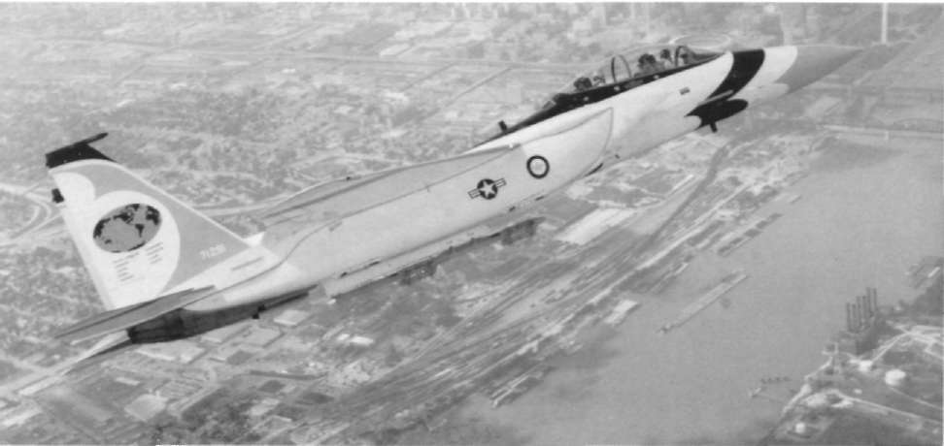
Modern lighter paint schemes tend to be rather
T H E EAGLES RECORDS
dull and. apart from unit markings, are much of a Date
Altitude
Time
Pilot
muchness. The prototypes give rather more scope
(ft/metres)
in seconds
for originality. Most were "air superiority" blue with 16 Jan 75
9,843 (3,000) 27.57
Major Roger Smith
16 Jan 75 19,685 (6,000) 39.33
Major Willard
high-visibility orange trim. Aircraft 71-0283 started Macfarlane
16 Jan 75 29,528 (9,000) 48.86
Major Willard
out basically blue with bright yellow trim and later Macfarlane
assumed the markings of the USAF Flight Dynamics
16 J a n 75 39,370(12,000)
59.38
Major Willard
Macfarlane
Laboratory Advanced Environmental Control Sys-
16 Jan 75 49,212(15.000)
77.02
Major Dave Peterson
tem. This displayed a bald eagle motif on the fin, 19 J a n 75 65,617(20,000)
122.91
Major Roger Smith
26 Jan 75 82,021 (25,000) 161.02
Major Dave Peterson
plus a shark's mouth and eyes on the nose in black, 1 Feb 75 98,425 (30,000) 207.80
Major Roger Smith
white, and red. The canopy was also outlined in red.
F-15A 71-0286 appeared lot a while in the air
Perhaps the most difficult F-15 for the aspiring
superiority blue which matched absolntelv no back-modeller to portray is the best known of all, serial ground in the air and this also had red trim around number 72-0119, which was the seventh FSD air-the canopy while 71-0287 was white with orange trim d a f t . This was the famous "Streak Eagle", which, and differed from the others by having a small between January 16,, and February 1, 1975 set square anti-spin parachute box mounted on the rear numerous time-to-height records.
fuselage above the engines.
"Streak Eagle" was not a standard F-15, but was 71-0289 and 71-0290 are MCAIR's own aircraft
stripped down to save weight. A m o n g the items and. early in the 1980s, were sporting a gloss white deleted were the gun, radar and non-essential
scheme with gloss dark blue trim rather similar to avionics. flap and speed brake actuators, one of the that applied to the early F-18s.
two generators, the utility hydraulic system, the tail As far as paint schemes went, however, the second hook and even, to save just 401b (18kg) of weight, the F-15B (71-0291) clearly held the prize. Originally paint.
finished in air superiority blue, it has been grew Certain other items of equipment had to be added
tri-coloured in Bicentennial markings in 1976, when for the attempt, apart from specialised recording it flew with and without a nose probe while, as the gear. These included an instrumented nose probe, a
"Strike Eagle", it featured both desert-type browns battery-powered radio and a hold-back device to
and "European One" dark greens. More recently as Below: Arguably the most attractive colour scheme worn by any the Advanced Capability Demonstrator, it has re-Eagle, MCAIR's two-seat demonstrator donned Bicentennial verted to grey.
colours for a while in 1976.
14
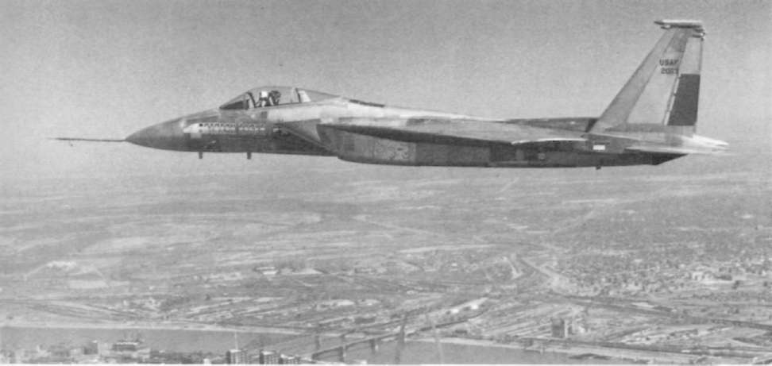
allow the engines to be run up to full power on the Grumman F-14 Tomcat was about 18 months earlier
runway without dragging the tyres around the wheel in timing than the F-15 and is a magnificent fleet air rims. Only the minimum fuel necessary for each defence interceptor and. less generally recognized, a mission was carried and, to preserve balance, "Streak fine close combat fighter. Unfortunately it was also Eagle" had to be ballasted. In all, it was some 2,8001lb colossally expensive.
(1,270kg) lighter than a standard F-15A. The three pilots who took part in the record attempts had to Eagles for the Navy?
wear full pressure suits and the records they set are shown in the accompanying table.
Seeking a cheaper alternative, in July 1971 the US
Secretary of Defense requested the USN to examine
"Streak Eagle" colouring
the possibility of a navalized Eagle. M C A I R duly produced a modification study which showed a con-The time of year was selected to give optimum siderable weight increase while a Navy study group conditions for the record attempts, which were made also concluded that both weight and cost would rise from Grand Forks A F B , North Dakota. The first five and that performance would fall to unacceptable
records were formerly held by a US Navv F-1B levels. Basically, the F-15N would have required Phantom 11 and the final three by a modified Foxbat.
stressing for catapult launch and arrested landings.
In all, it was a very satisfying exercise for the A i r The narrow-track main gear was a distinct disadvan-Force.
tage-, while it would also have needed to be made Without its paint "Streak Eagle" looks rather odd much stronger. The wings would have required high and the different skin textures are readily apparent; lift devices to reduce approach speed to an accept-the aluminium, titanium and composite materials able level and the 12deg approach angle would have contrasting well. The only touches of real colour are made deck landing a marginal affair, largely as a the USAF markings and the "Streak Eagle" motif on result of poor visibility over the nose. The F-15N was the nose and fins. It was eventually retired to the dropped, to be resurrected again in March 1973
USAF Museum at Wright-Patterson AFB, Ohio.
when the same objections held good. Ultimately, the One Eagle that never was belongs to the develop-high attrition rates experienced by American-built ment phase, this being the navalised F-15N. The aircraft in the Arab-Israeli October War of 107.") convinced the powers that be that no useful purpose Below: Rather less appealing, "Streak Eagle" (72-0119) set eight would be served by building austere fighters and the time-to-height records in early 1975 and is now preserved in the USAF Museum at Dayton, Ohio.
idea was finally buried in May 1974.
15
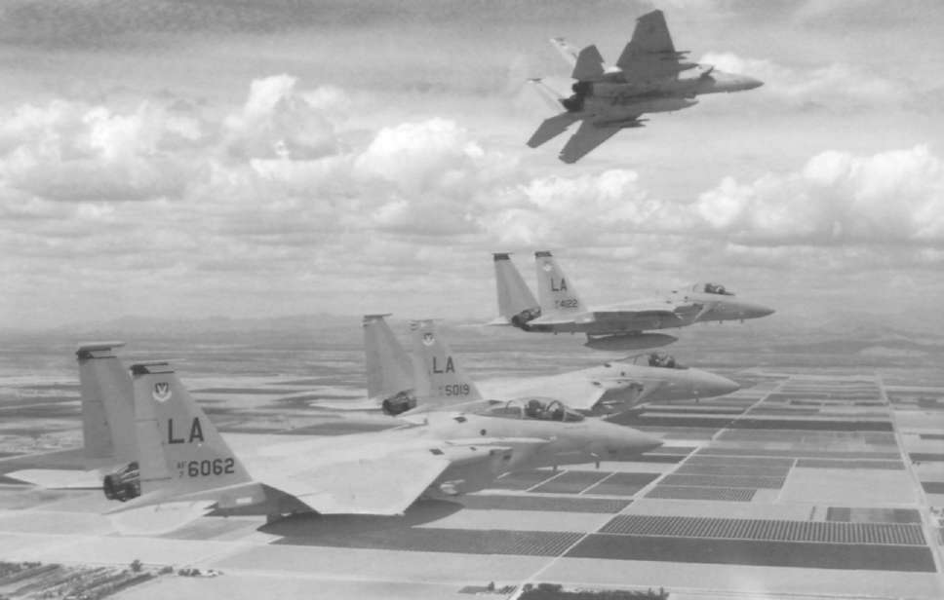
2
The Baseline Aircraft
THE EAGLE was designed as an air superior- not only to survive the deadly arena of air combat, ity fighter par excellence. We have already but also to be successful even when fixing inferior seen the measures taken to enable it to fighters or when heavily outnumbered.
ontfly any other actual or projected lighter in the To have an outstanding Hying machine and deadly
world. However, to be able to outfly them is not
weaponry obviously helps, but, by itself, it is not enough; it also needs to be able to outfight them.
enough. Pilot quality is a further asset which can be Weaponry is, of course, an important part of this, attained by first class training, but even this does not but the missiles and gun carried by the F-15 are little account for the disparity in performance between the or no different to those carried by the Phantom ace and the average squadron pilot. Ultimately, no during the Vietnam conflict. In future, this will matter how good the average squadron pilot might change, but in the early service days of the E-15, this be and how superior his aircraft, something more
was the case.
was needed, especially in the worst case scenario Eighter conflict down the years has shown that a
envisaged, that of an all-out war in Central Europe in small proportion of pilots have scored a disproportionate amount of the total victories. These aces Below: Bearing the markings of all four squadrons of the 405th Tactical Training Wing, four F-15A Eagles enter the approach obviously had sonic special quality that enabled them pattern at Luke AFB, Arizona.
16
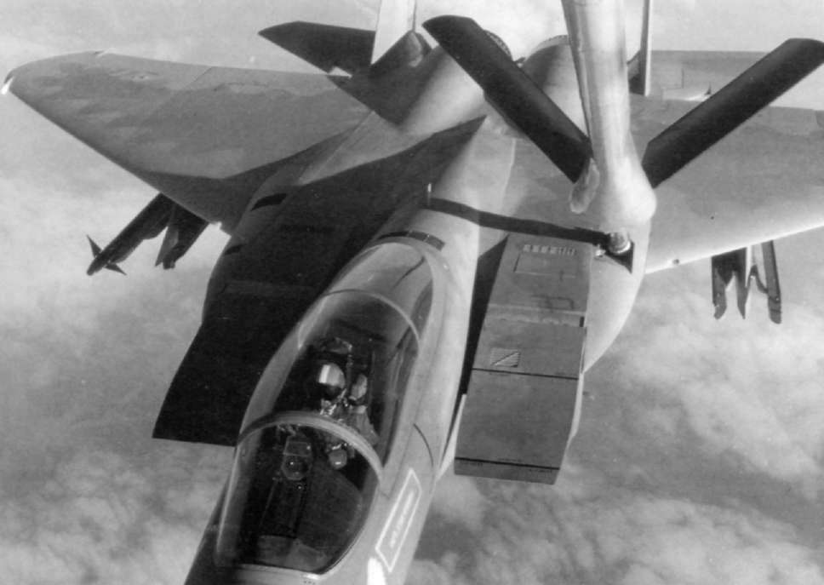
Above: The excellent field of view possessed by the Eagle is Unlike the F-14, which was considered to need a
clearly conveyed in this picture of an F-15A receiving fuel from a Strategic Air Command KC- 135A.
two-man crew to make the best use of the clever
systems, M C A I R felt that they could make every-which N A T O air forces would be heavily outnum-thing one-man operable without pushing his work
bered.
load beyond reasonable limits. Twin-seater fighters The quality that distinguishes the ace f r o m the have certain advantages, but also some drawbacks.
average pilot is a sort of alertness, which makes him One of the main disadvantages of a two-man crew
difficult to surprise and enables him to use the was the need for them to constantly communicate surprise factor to his own advantage. The recorded with each other while, in the Phantom, the use of history of air combat shows that something like four some weaponry needed concerted action by both
out of every five victims were either unaware of crew members which also complicated matters.
being under attack or only became aware when it was Thus, the USAF definitely wanted a single-seat
too late to take effective counter-action. The buzz-fighter to remove these problems.
word is "situational awareness" and the F-15 was The most obvious item to improve situational
designed to allow the pilot to maximise this factor.
awareness on the F-15 is the bubble canopy, which In essence, it involved giving the pilot the best allows the pilot a field of view extending through possible chance of detecting an opponent, whether 36()deg. Clever electronics or no, the pilot still fights target or threat, earlier than he himself could be looking out of the window unless it is at night or in detected. The pilot thus needed a superior radar and bad weather. His radar cannot scan astern and,
oilier avionics plus a cockpit layout that demanded although radar warning devices should inform him
the least time spent head down in the "office", of a threat developing f r o m astern, if the threat coupled with good all-round visibility.
aircraft is not using radar, but coming on in true 17
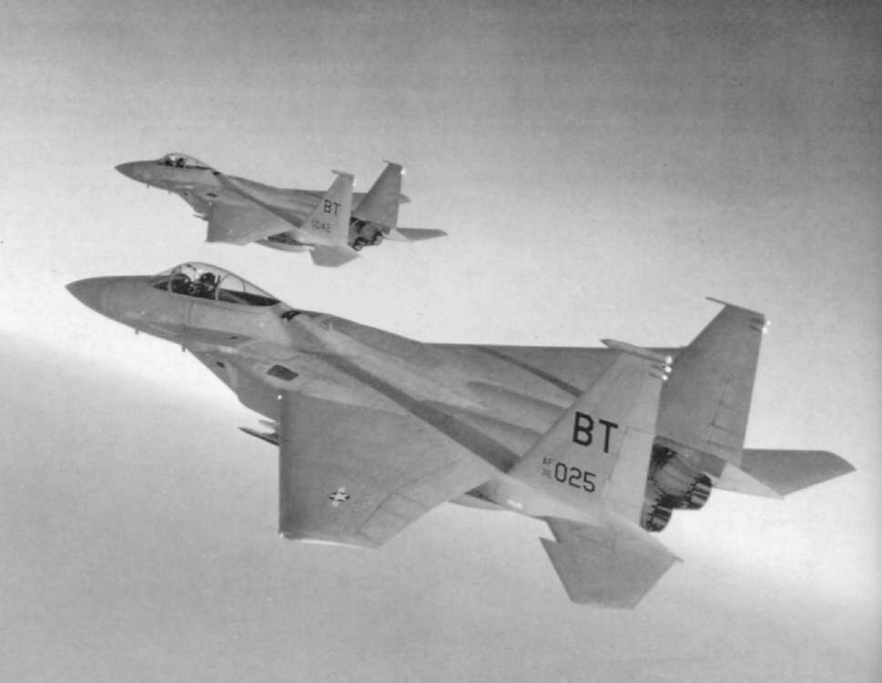
Richthofen style, then the warning kit is of little use, T h e greatest difficulty in visual acquisition is know-and the pilot's safety is then dependant on his own ing exactly where to look and it is in this area that the or, more probably, his wingman's sharp eyes. In a radar helps the pilot under these circumstances.
confused multi-bogey dogfight at close quarters, the Target identification is always a problem and an
value of good rear vision cannot be overstated.
identification friend/foe transponder is an essential The greatest electronic aid to situational awareness part of the kit. A comprehensive electronic warfare is, of course, the radar, which is the Hughes A N /
system is housed in a compartment behind the
APG-63. This has a maximum detection range of up
cockpit, aerials for this being scattered around the to 100nm (185km) depending on target size, aspect aircraft. Radar warning aerials are mounted in a slim and reflectivity, and pulse-Doppler modes allow it to pod at the top of the left fin, while electronic
look down and detect targets by filtering out un-
countermeasures antennae are found in an even
wanted ground returns. Operating in the I/J band, it slimmer pod on the top of the right fin (the pro-has a multiplicity of modes which can be selected by totypes had pods of even size); at the top rear of the the pilot to suit the circumstances. These include right fin, the extreme tip of the boom supporting the search, look-up, look-down, target acquisition and left tail surfaces and on the leading edges of both missile guidance, plus a dogfight mode which gives wing tips.
auto-acquisition on targets within 10nm (18.5km), automatically setting a target designator box over the Below: Silhouetted against the setting sun, two Bitburg-based Eagles of the 36th Tactical Fighter Wing perform a routine target on the head-up display and thus aiding in training mission. Fin-tip ECM/ESM fairings and the "snag" in visual acquisition.
the horizontal stabiliser can be clearly seen in this fine in-flight study of the F-15.
IS
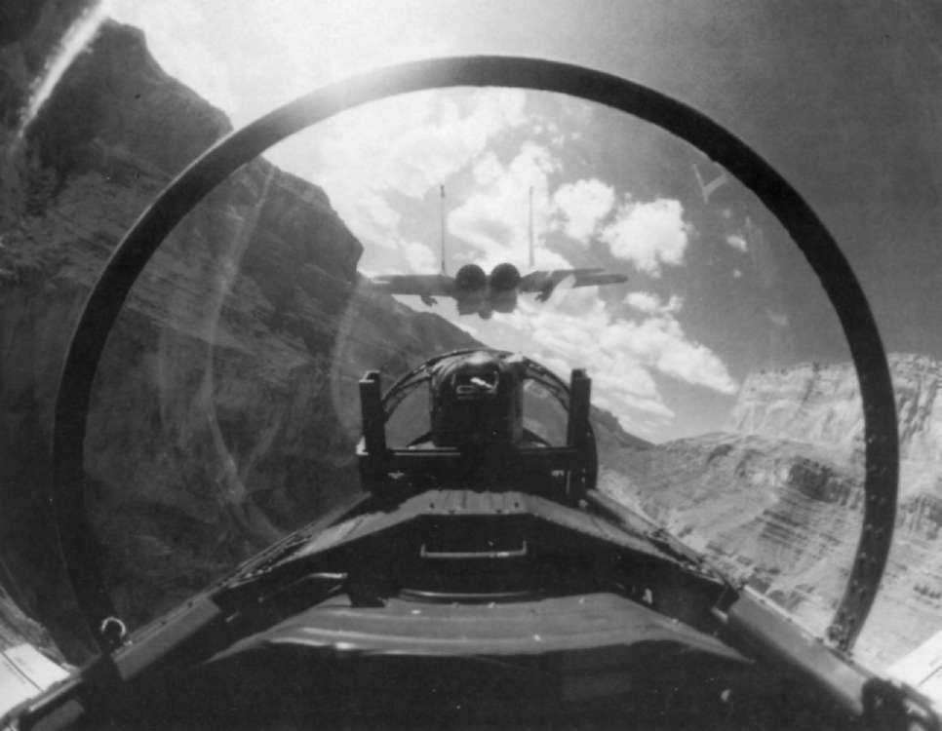
The radar warning system detects and classifies
Firstly, nothing that the pilot will need in flight is hostile radar emissions and displays the resulting positioned behind the line of his elbows. Secondly, data in the cockpit. ECM takes the f o r m of deception the aircraft has deliberately been made very easy to jamming such as rangegate stealing; noise j a m m i n g fly. Thirdly, information presented on the cockpit and chaff dispensing. Infra-red flares are also car-visual displays is in an alpha-numeric format. This is ried to decoy heat-seeking missiles.
particularly important in the case of radar, where, previously, raw data which needed interpretation, High work load for pilot
was displayed.
Naturally, much of the essential information can
The pilot has to fly the aeroplane with stick, be transferred to the Head-Up Display (HUD), rudder pedals and throttles; keep a sharp look-out where it is focussed at infinity, thus enabling the pilot lor other aircraft; navigate; communicate with other to look at distant objects and yet read the information aircraft in the formation and ground control and, at without having to refocus his eyes. In addition, a new the same time, monitor information gathered by the concept—that of "Hands On Throttle A n d Stick"
sensors. The work load is high and the cockpit has (HOTAS)—was pioneered for and by the F-15.
been designed to reduce it to acceptable levels.
Pilots normally fly with their left hand on the throttle(s) and their right hand on the stick, and it is Below: Not exactly representative of the Eagle's usual operating altitude but an interesting picture nevertheless, a pair of 405th obviously a disadvantage in combat to have to use TTW F-15s play follow-my-leader along the breathtaking one hand to fumble with various switches, or, even scenery of the Grand Canyon, not far from Luke Air Force Base, Arizona.
worse, change hands to do so, while trying to keep a 19
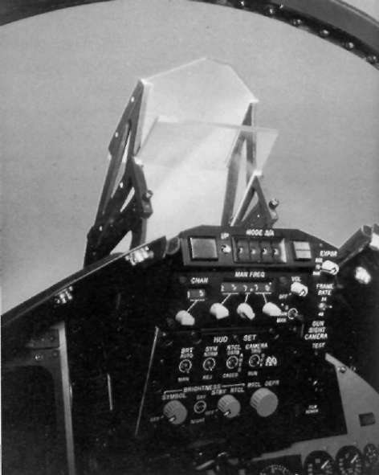
small, distant and rapidly moving target in sight.
sions of single-seat fighters and the F-15 is no
The HOTAS solution was to put all the controls
exception.
and switches generally required in combat on either Originally designated TF-15A, the two-holer has
the throttles or the stick. Things had been moving in since become the F-15B. The cost of an F-15B is such this direction for some considerable time, it being a that it precludes its use solely as a pure trainer and it process that had started with the gun button on the therefore has full combat capability—in war, it would stick in World War 1, and H O T A S is merely the be flown as a single-seater. In many fighter designs.
logical end product of this trend, with much of the the extra crew position can only be achieved at the radar functions and weaponry controlled f r o m these expense of something else. Often a fuel tank has to two positions, to say nothing of the speed brake.
be sacrificed but the F-15 was produced with the
extra cockpit in mind, with a bay just aft of the front Manual dexterity an essential
seat large enough to house the extra cockpit.
In single-seat variants, this bay represents growth Effective operation naturally calls for a high de-space for the addition of new black boxes as and
gree of manual dexterity; one pilot, when asked if he when they become necessary and, with fighters likely needed to be a concert pianist, replied "no, a virtuoso to remain in service f o r 30 or 40 years, growth clarinetist!" Another frequently used item, the com-capacity is essential. It may also be that, despite the munications panel—traditionally sited on one or overwhelming accent on a pure air superiority other of the side consoles—has been located in the fighter and the slogan "not a pound for air to front centre top of the instrument panel, where it is ground", M C A I R foresaw the possibility of an attack in the pilot's peripheral vision as he looks through variant for all-weather use which would need to be a the H U D . It is flanked by the radar display on the two-seater anyway. If this was indeed the case, they left and the tactical electronic warfare display on the kept it mighty quiet at the time.
right, to which the same comments apply.
This accent on grouping essential kit around the
Below: Dominating the upper cockpit, the F-15 HUD (head-up display) is a vital aid in aerial combat. HUD controls are located H U D , although valuable in allowing the pilot to on the panel directly below.
concentrate his vision outside the cockpit, does place rather a premium on his line of sight being forward, and this does to a degree negate the value of the outstanding rear visibility. To offset this, no less than three rear vision mirrors are placed around the
canopy bow.
Needles and dials prevail
By the standards of the 1980s, the instrumentation looks rather old fashioned, with a plethora of dials.
although it must be admitted that there are not as many as on some previous aircraft such as the F-5E.
The combiner glass-type H U D has a narrow field of view by present day standards, but, having said that, it should not be forgotten that, in concept, the F-15 is also quite elderly.
Modern fighters are too complex and too expen-
sive to risk simply showing a pilot the "taps" and then sending him off to fly it. Simulators have great value, but lack the physiological sensations experienced during real flight. Accordingly, it has long been standard practice to build two-seater training ver-20
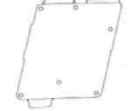
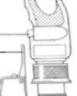

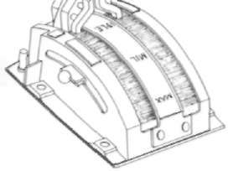
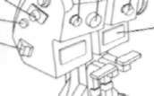
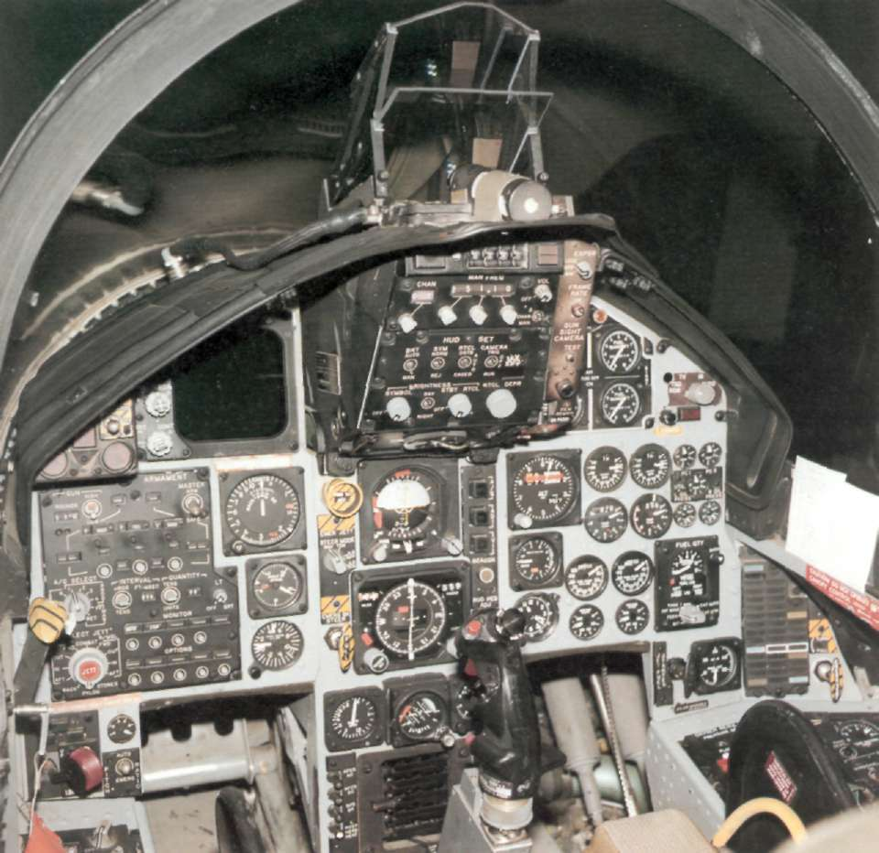
1 2 3 4
1
5
9
The 'front office' of the F-15 Eagle
2
interceptor is an interesting mixture of old
8
6
and new technology. Controls sited on the
3
7
throttle quadrant (left) are as follows:
6
1: Microphone switch. 2: IFF interrogate
button. 3: Target designate control:
4: Gunsight reticle stiffen/reject
5
short-range missile. 5: Radar antenna
elevation control. 6: ECM dispenser switch.
4
7: Weapon selector. 8: Spare. 9: Speed
brake control.
Right: The control column also features
various switches, these comprising: 1: Trim
button. 2: Weapon release button. 3: Radar
auto-acquisition switch. 4: Autopilot-nose
gear steering release switch. 5: SRM/EO
weapon seeker head cage/uncage control.
6: HUD camera and gun trigger.
l21
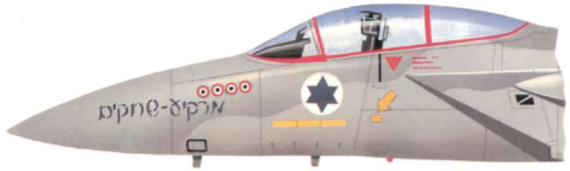
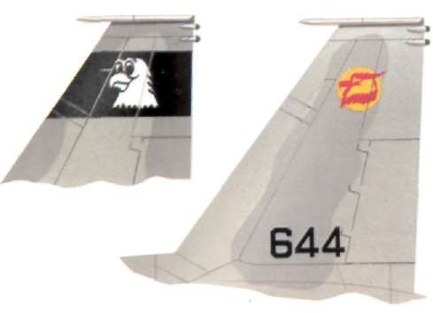
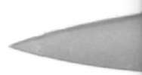
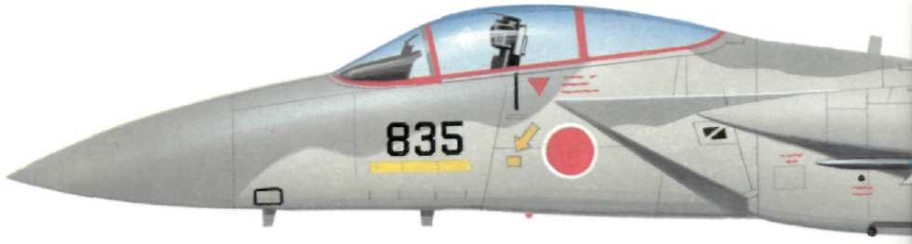
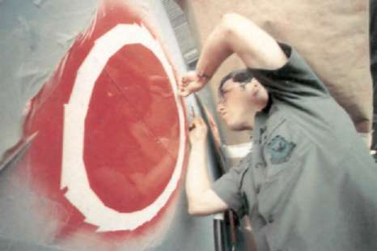
Left: The first two JASDF F-15Js flew from the USA to Gifu in March 1981, final touches like national insignia being applied while in transit at Kadena, Okinawa.
Right: The first fully-fledged JASDF unit to receive the Eagle was No.202 Squadron, No. 5 Wing at Nyutabaru which took delivery of the F-15J in 1982.
Below: The 35th F-15J Eagle to be produced for the JASDF is depicted in the markings of No.203 Squadron, No. 2 Wing at Chitose.
Left: These two fin profiles depict Israeli Defence Force/Air Force F-15A No. 644 which features a squadron marking embodying a bird of prey.
Below: Israeli F-15A No.695 displays novel artwork in the shape of four Syrian roundels, these presumably depicting 'kills', as well as the name 'Skyblazer' in Hebrew characters.
22

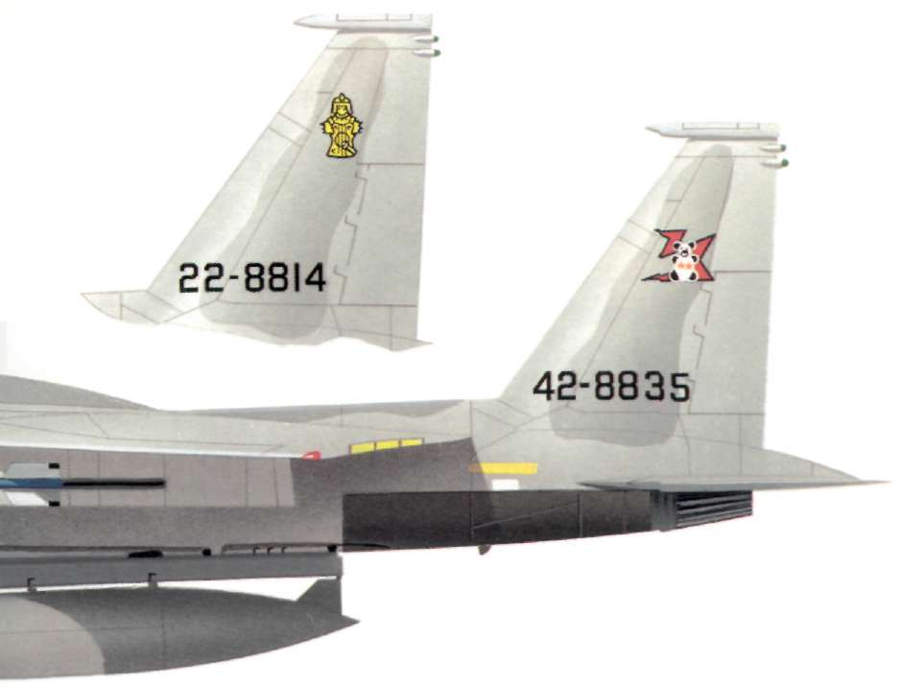
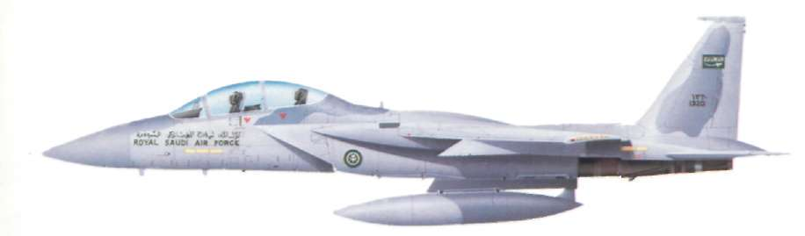
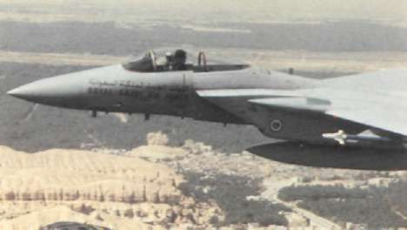
Above: One of the 15 two-seat F-15Ds purchased for service with the Royal Saudi Air Force, the example portrayed here is from No. 13 Squadron which is one of three RSAF units currently operating the Eagle.
Right: In addition to the trainer model, Saudi Arabia also received some 47 F-15Cs like the Sidewinder-armed machine seen here.
23
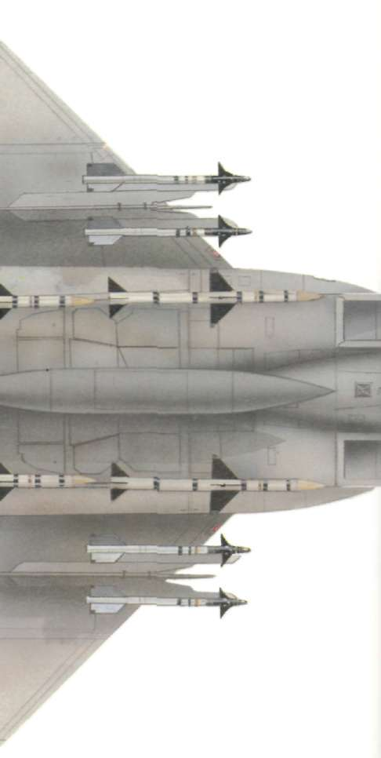
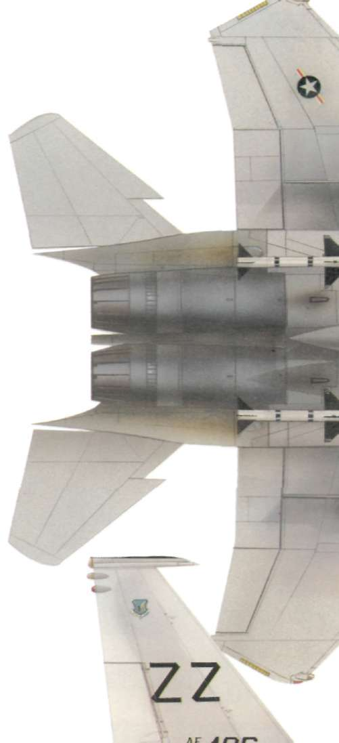
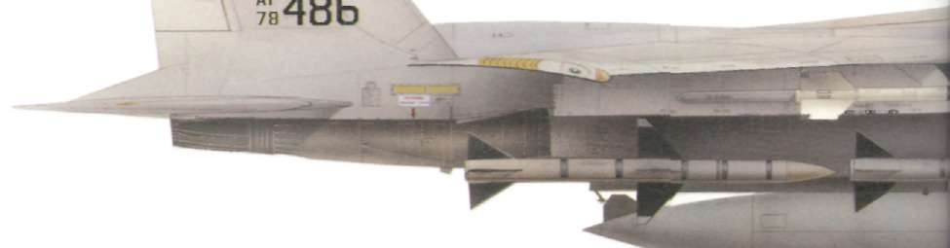
Above and below: The 18th Tactical Fighter Wing at Kadena, Okinawa was the first Pacific Air Forces unit to convert to the Eagle, in the process becoming the first Wing to get the much improved F-15C. One of their early aircraft is shown here with a full array of missiles.
24

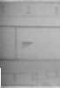
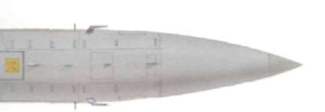

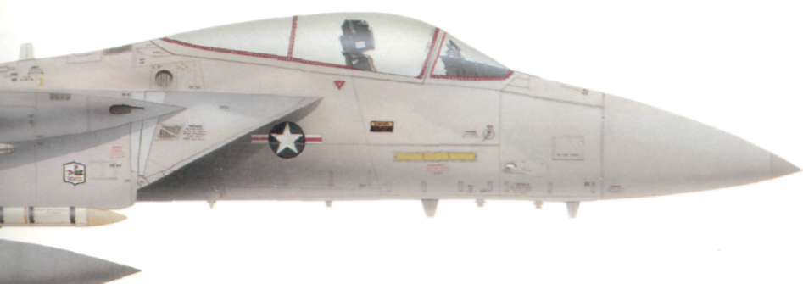

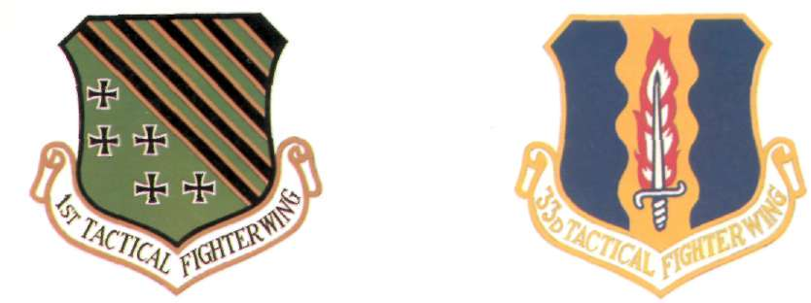
The first fully-operational USAF unit to acquire the F-15A Eagle Resident at Eglin AFB, Florida, the 33rd TFW recently became was the 1st TFW at Langley AFB, Virginia. the first Wing to receive MSIP-standard F-15Cs.
This distinctive marking—depicting an Eagle intercepting a With regard to overseas-based units, the 36th TFW at Bitburg, satellite—was applied to the AS AT test machine. West Germany, was the first to acquire the F-15.
25
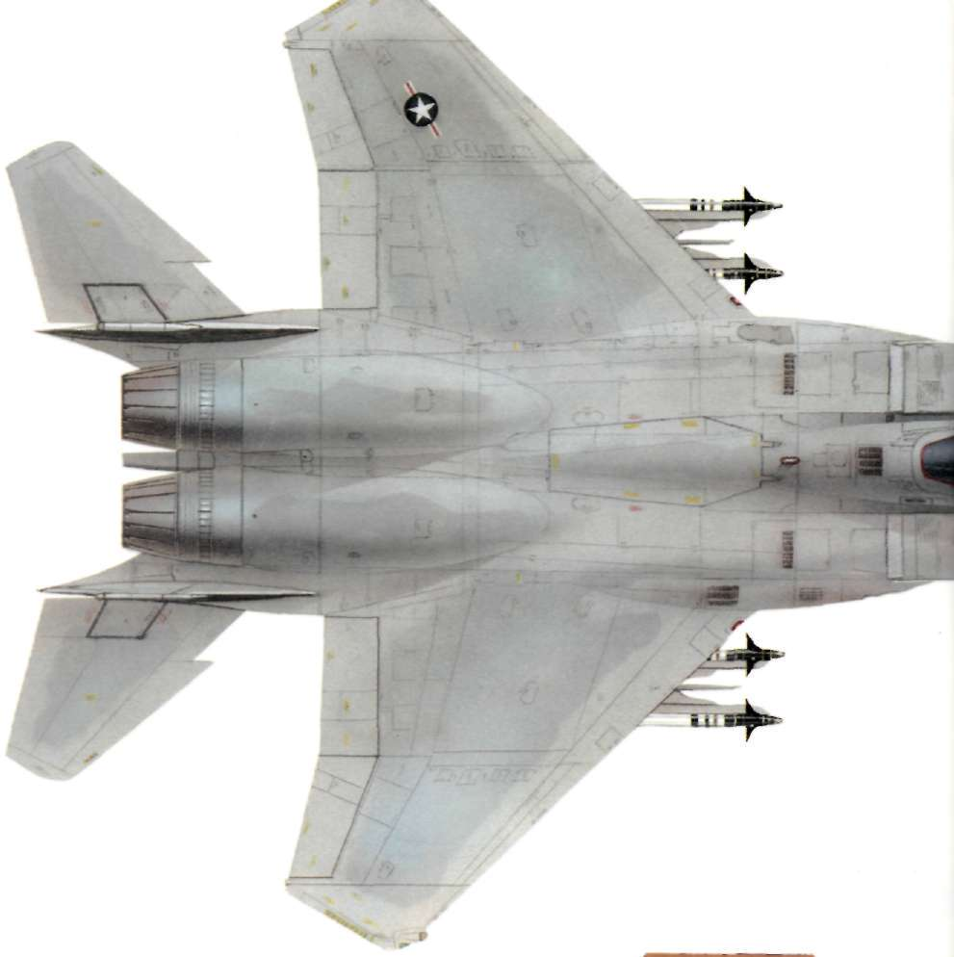
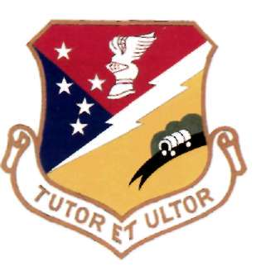
Above: The camouflage pattern, positioning of US national insignia and the Eagle's distinctive wing and horizontal tail planform may be seen in this plan view of an F-15C from the 18th TFW at Kadena, Okinawa.
Right: Located at Holloman AFB, New Mexico, the 49th TFW
was one of the first TAC units to convert to the F-15A.
26
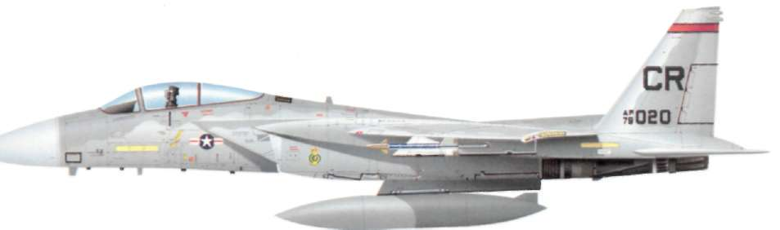
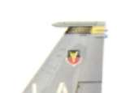
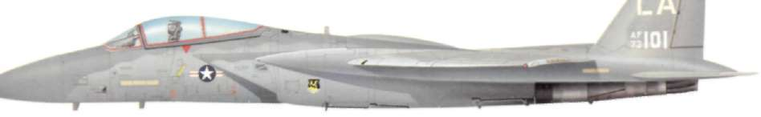
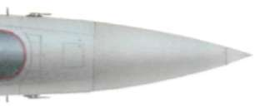
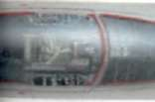
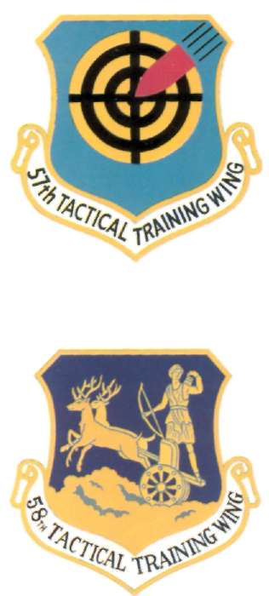
Right: Resident at Nellis AFB, Nevada, the 57th Tactical Training Wing is one of TAC's most important units, being tasked with evaluating weapons and tactics.
Below right: TAC's first Eagle unit was the 58th TTW at Luke, Arizona, this later metamorphosing into the 405th TTW.
Above: Initially equipped with the F-15A variant, the Soesterberg-based 32nd Tactical Fighter Squadron now operates F-15Cs like that shown here.
Below: An early production example of the F-15A in the markings initially applied to Eagles of the 58th TTW at Luke AFB.
27
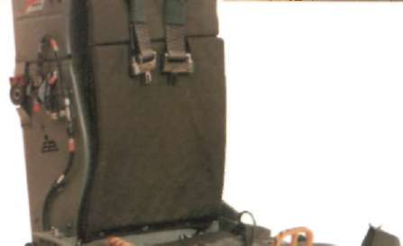
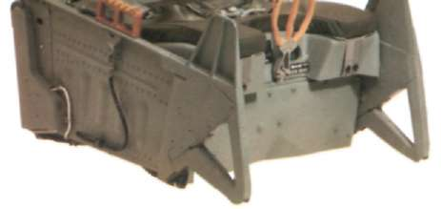
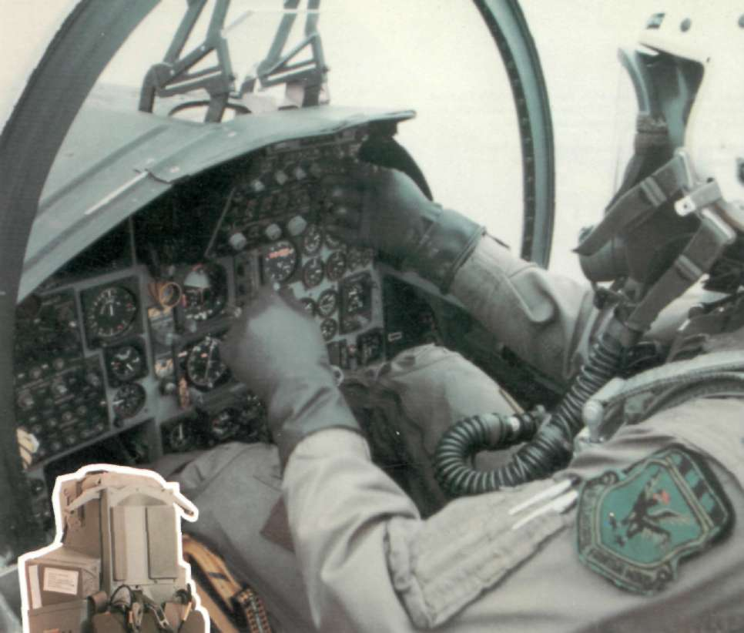
Above: Wearing the modern fighter pilot's traditional "bone dome" and weighed down by numerous other bits of kit including oxygen connectors, a G-suit and parachute harness, a pilot runs through pre-flight instrument checks before a routine training sortie over a combat range area somewhere in the United States. This kind of scene is enacted daily at Eagle bases around the world, the type now being well established in service in the USA, Europe, the Middle East and the Far East.
Left: The current F-15 Eagle ejector seat is the ACES II type, also fitted to the General Dynamics F-16 Fighting Falcon.
Possessing zero-zero capability, it takes just five seconds from initiation of ejection to full parachute deployment.
28
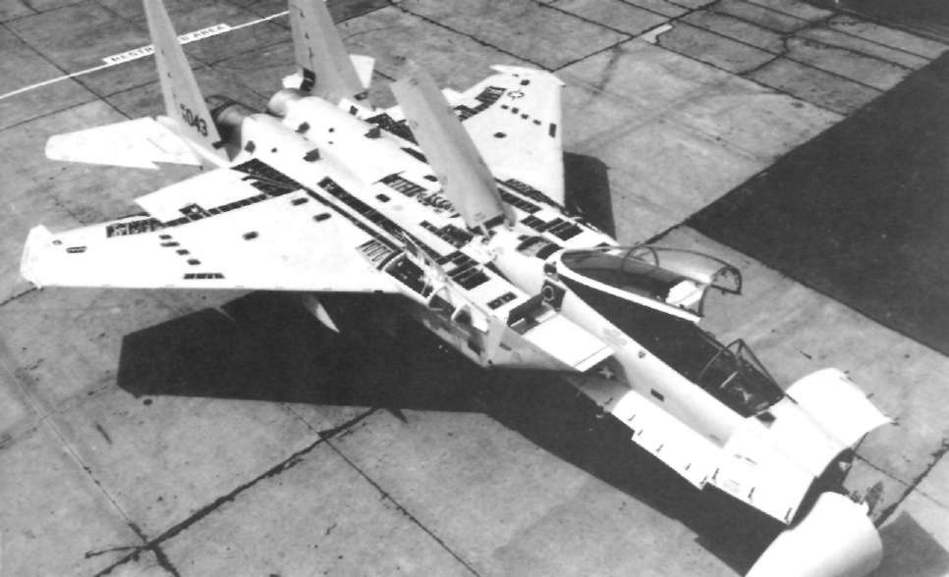
The only external difference between the F-15A
eller's nightmare. Trouble was experienced with the and F-15B is the longer canopy needed to cover the augmentor sealing flaps, commonly known as "tur-two seats. As far as performance is concerned, the key feathers", and maintenance was time-consuming two models are identical for all practical purposes, and costly. The preferred solution was to omit them including combat radius and range. The front cock-which resulted in a considerable saving. Base drag pits of both are identical, but the rear cockpit instru-increased slightly, but not enough to adversely affect performance, but the exposed lattice of" sliding run-mentation in the F-15B is austere. All the flight ners and push rods that operate the con-di nozzles controls are there, as are the radar and the main looks very complex.
instruments, including the radar V D U , but there is no tactical electronic warfare display, armament
panel, fuel gauge or caution light panel. The H U D is Crew access
deleted for it would be useless unless the guy in the front seat had a glass head. The side consoles are Access to all F-15s is usually via a ladder which is similarly bleak. The ejection seat originally fitted to part of ground support equipment, but, in emergen-both models was the Escapac but this has since been cy or when deployed (the F-15 is self-starting and replaced by the ACES I I .
does not need ground power units), an integral
ladder that pulls clown f r o m the lower left fuselage Modified exhaust nozzles
beneath the canopy, can be used, in conjunction with an integral recessed hand-hold higher up. This
flimsy looking arrangement is unpopular with the
Externally, the early model F-15s have seen almost crews, who prefer something more substantial.
no change f r o m the first production aircraft, but one thing that has occurred on many aircraft is a mod-The final factor built into the F-15 is maintainability. An amazing amount of the skin, some 570sq ft Below: In addition to being outstanding in the air, the F-15 is (53sq m) in total, consists of access doors and panels, also a boon to maintenance personnel, easy access to component aparts for rapid servicing being a keynote of design. Looking a bit like Swiss 85 per cent of which can be reached without recourse cheese, this F-15 shows just how many access panels there are.
to work stands.
29
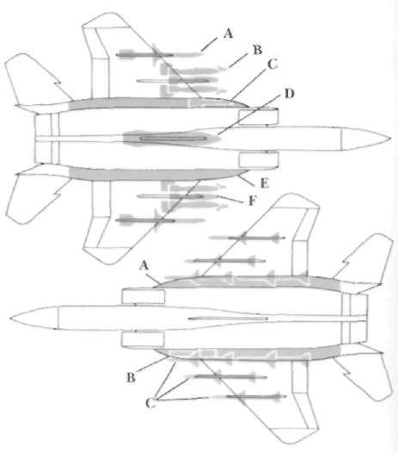
3
Missions and Weaponry
THE ORIGINAL missions foreseen for the weight penalty is incurred, which results in reduced F-15 were threefold. They were: (a) the performance. T h e F-15A and E-15B have a fuel interception of high-flying supersonic bom-fraction of .28, which was hoped to be offset by the bers and reconnaissance aircraft; (b) the attainment economical F100 turbofans. In practice, it proved to of local air superiority in the combat area; and (c) the be a little short-legged, a failing that was addressed escort of friendly strike formations over enemy terri-by later variants. However, endurance could always tory.
be increased by carrying three 600 US gal tanks on The qualities needed for the high-altitude in-the centreline and under the wings, to give a further terception mission are the ability to get o f f the 11,7001b (5,307kg) of fuel, albeit at a cost in perform-ground quickly, with a m i n i m u m of ground support ance. In-flight refuelling on the homeward leg was equipment; a tremendous rate of climb to reach a yet another possibility.
last, high-flying attacker before it can pull away out of range; good high-altitude performance and man-Weapons options vary according to model and mission. These oeuvrability in order to achieve an attacking position drawings illustrate just two of the many alternatives. Below: An F-15E employed in the strike role could carry AGM-88A and to prevent the hostile aircraft f r o m escaping; a anti-radar missiles (A); AIM-9 Sidewinders for self-defence (B); the integral 20mm Vulcan M61 gun (C); Pave Tack target reasonable radius of action in order to make the designation pod (D); FAST-pack conformal fuel tanks (E); plus intercept as far out from base as possible; and, "smart" or "dumb" bombs (F) on multiple ejector racks.
Bottom: A dedicated air defence F-15 could in future utilize the finally, good detection capability combined with Hughes AIM-120A AMRAAM missile (C), employing lethal weaponry.
FAST-packs (A) to extend patrol endurance, and the integral Vulcan gun (B).
High thrust to weight ratio
The first and last of these factors was built in from the start and weaponry will be examined separately.
The tremendous thrust/weight ratio of 1.4 to 1 at combat weight with 50 percent internal fuel gave the rate of climb that was so well demonstrated by
"Streak Eagle". The thrust/weight ratio, combined with low wing loading and a fair amount of body lift, conferred the required high altitude performance; top speed is Mach 2.5 plus, service ceiling 65,000 ft (19,800m); absolute ceiling reached in a zoom climb is 100,000ft (30,480m) although there is little combat capability at this level while the high rate of climb can also be related to the rate of acceleration.
Only in radius of action is the Eagle a bit restricted, the optimum fuel fraction—i.e. internal fuel weight expressed as a fraction of clean take-off weight with full air-to-air weaponry—being generally considered to be about 30. More than this and a structural
30
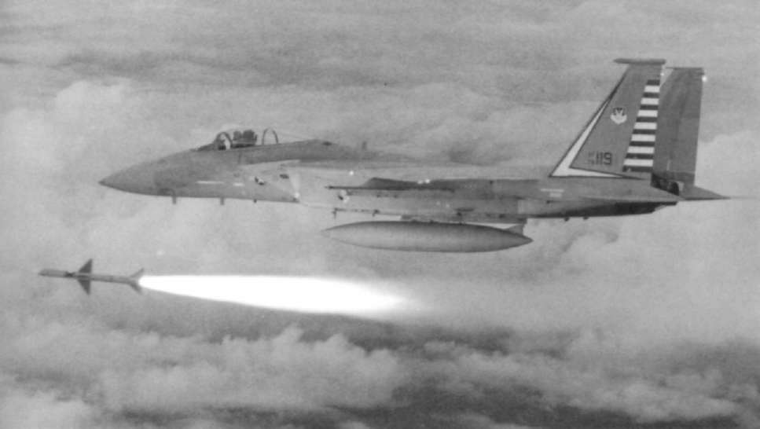
The air superiority mission calls for the ability to to high subsonic speeds, while the Eagle would be detect and shoot at longer range and generally able to operate at supersonic speed at medium operate at beyond visual distance better than one's altitude. This speed advantage would enable it to opponent. It calls for the engagement of targets pick its spot f r o m which to attack.
flying very high or very low. It requires great man-Once visual range is reached, the Eagle's great
oeuvrability and acceleration once at very close range dogfighting capability comes into its own. A I M - 9
as well as a weapons system that allows "snap-shots"
Sidewinders will be the preferred weapon here, with to be made at targets of opportunity, with the the gun available as a close-range "snap-shot"
minimum time taken in lining up, selecting and
weapon. One school of thought maintains that if the arming the chosen weapon. It needs the ability to fighter gets within gun range, the pilot has made a sustain damage and still be able to continue the
tactical error, but, in a heavily outnumbered situa-mission. It needs quick refuelling and rearming on tion, gun-range fighting will be almost inevitable.
the ground, so as to t u r n around and get back in the air again. Finally, it needs combat endurance, to Superior performance and armament
outlast the enemy in the fight, both in terms of fuel and weaponry.
T h e acceleration and turning capability of the
The F-15 fulfils all those conditions admirably. It F-15, plus its tremendous rate of climb, will give it the has good beyond visual range (BVR) capability with edge over any other tighter currently thing. The
the APG-63 radar and A I M - 7 F Sparrow missile. This final quality, that of outlasting the enemy in the fight, is particularly important in the heavily outnumbered is well served by the carriage of eight missiles, with scenario, where it would be important not so much to the gun as a last resort weapon, although endurance attempt to destroy an entire hostile formation at long could have been better on the F-15A. Close combat distance but rather to kill one or two to disrupt it, calls for the prodigious use of afterburner and this make it feel threatened, and put it on the defensive.
simply gulps fuel. T h e increasing lethality of modern Its look-down, shoot-down capability is yet another missiles is making the process of disengagement
advantage when defending against a low-level strike in a friendly defensive environment. T h e low-level Below: Armament available to the Eagle comprises Sparrow and Sidewinder missiles plus the Vulcan cannon. Here, a 48th FIS
attackers would be speed-restricted, almost certainly F-15A lets fly with a Sparrow missile.
31
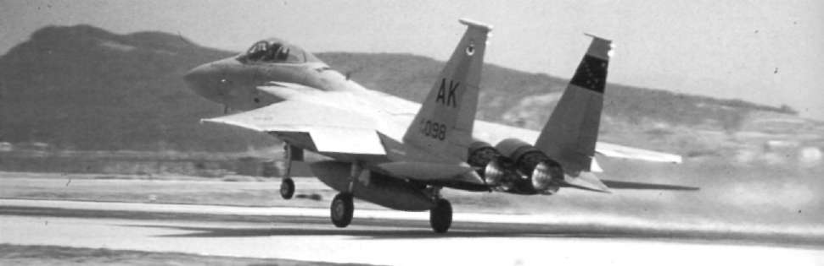
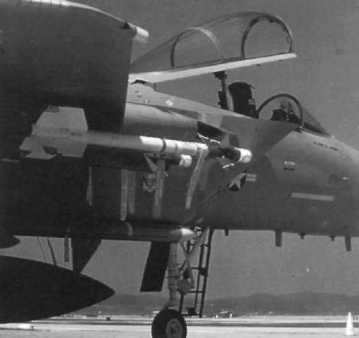
from close combat ever more perilous and, if possible, it is better to wait for the opposition to cut and run first.
The escort mission is the most difficult of all. This is because it involves operating over hostile territory, where the advantages of ground radar and control, ground defences, short distance to base and dedicated ECM all lie with the enemy. In this environment, the F-15 is forced to rely almost entirely on its own equipment and resources.
Defending a strike force
The escort mission is no longer simply a matter of flying out in formation with the bombers or strike aircraft and defending them f r o m hostile fighters, if indeed it ever really was. It is a combination of different functions. Thus, a fighter sweep might Above: Sparrow and Sidewinder missile locations are easily range up the line of the strike force ahead of it while seen in this view of the forward fuselage of the Eagle. The large canopy area is also of note.
close escort would most likely involve a flight of fighters following the strike force at the sort of distance at which enemy interceptors would t u r n in factor for F-15 pilots would be the measures built behind to launch their missiles, say four miles into their fighters to increase their situational aware-
(71/2km) back. A barrier combat air patrol (BAR-
ness, and this would be the Eagle's main advantage.
CAP) may be flown to a position between the line of coupled with its exceptional fighting abilities which the strike force and the nearest enemy fighter base have already been detailed.
from which a reaction might be expected.
The air-to-air weapons carried are the AIM-7F
If circumstances permit, the BARCAP might be Sparrow, the AIM-9J Sidewinder in the early days set up over friendly territory, ready to interpose itself and, more recently, the A I M - 9 L plus the M61 20mm between the strike force and the defenders. Finally, cannon.
the escort may take the f o r m of a reception commit-T h e A I M - 7 F Sparrow is a semi-active r a d a r hom-tee that meets the strike force on its way home to ing (SARH) missile, which means that it is guided by dispose of unwanted visitors. Ideally, a combination of all these separate facets would be employed but it Below: F15 units may be only 15 minutes from the adversary, so is doubtful that there would be enough fighters to go such constant training as this 21st TFW machine is undergoing ensures that Eagle pilots would be ready if the wargames had to round. Regardless of circumstances, the decisive be played for real.
32
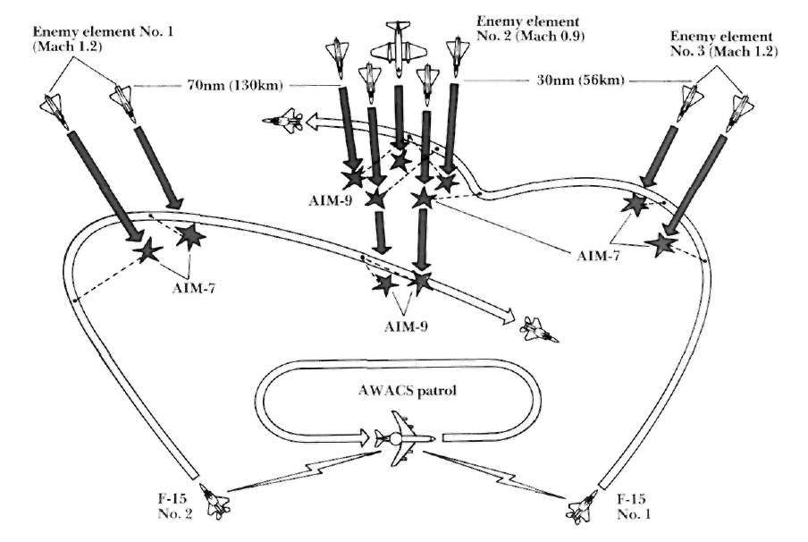
Above: Despite being outnumbered nine to two, when working emitted by the target aircraft. Smaller than Sparrow, in conjunction with an E-3 Sentry, the F-15 should theoretically emerge victorious by destroying adversaries at long-range with it is 10.08ft (3.07m) long, has a body diameter of 5in the Sparrow and then using Sidewinder to mop up the remnants.
(12.7m) and weighs 1721b (78kg). Maximum speed is This exercise, conducted on an instrumented range at Yuma, Arizona, resulted in destruction of all nine "targets".
Maeh 2.5 and range is 9.5nm (17.7km), although the qualifications that apply to Sparrow are relevant for radar emissions reflected by the target. This has the Sidewinder. Essentially a visual distance weapon, the drawback that the launching fighter has to keep the F-15 carries four on wing pylons. The warhead is
target illuminated d u r i n g the missile's flight, which small, just 22.41b (10.4kg) and its effectiveness against makes it predictable for far too long. The A I M - 7 F is a large bomber or a tough all-steel aircraft such as a large missile, being 12ft (3.66m) long with a body Foxbal must be in doubt. The guidance fins on the diameter of 8in (20.3cm). It weighs some 5031b AIM-9J differ from those of the A I M - 9 L quite (228kg) at launch and four are carried conformally considerably.
on the outside corners of the F-15's lower fuselage.
Finally, there is the gun. This is a six-barrel
Speed is about Mach 4 at altitude: rather less lower Gatling-type cannon with two rates of fire; 4,000 and down, and the stated range is 54nm (100km) 6,000 rounds per minute. It is very reliable, but the although in combat this would vary with altitude, ammunition could be better for its ballistic qualities target reflectivity, relative speeds and aspects. Effec-are not good.
tive missile range is always shorter against a target going away than against a closing target, the amount Weapons for the future
varying with the relative speed of target and fighter.
Intrinsically less accurate than an infra-red (IR) At some future point, the F-15 will be equipped homing missile. Sparrow compensates by having a
with new missiles. Sparrow will be replaced by the large warhead weighing 881b (40kg).
Advanced Medium Range Air-to-Air Missile or
Sidewinder is an IR homer and guides on the heat
A M R A A M . It will use inertia! mid-course guidance 33
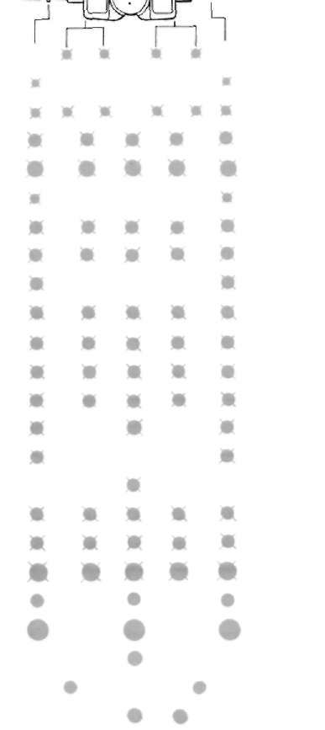
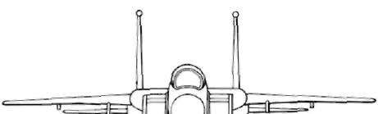
and active radar terminal homing. Unlike Sparrow, it will be a "fire and forget" weapon and, once launched, the F-15 will be able to break away immediately and seek another target.
Sidewinder is also scheduled to be replaced in the fullness of time by the Advanced Short Range Air-to-A i r Missile or A S R A A M . It will be faster than Sidewinder, though with about the same range and
1
will fly on body lift, thus having no flight surfaces. It 2
will be compatible with Sidewinder launchers and is 3
expected to use inertial mid-course guidance, with 4
terminal IR homing.
No matter how dedicated a fighter design may be
5
to the destruction of other aircraft in the air, inevit-6
ably it will at some stage have air-to-ground weapons 7
hung on it and be expected to perform the attack
role. So it was to prove with the F-15. The maximum 8
take-off weight of the F-15A was 56,0001b
9
(25,401kg), while its normal take-off weight in
10
fighter configuration, with eight missiles and internal 11
fuel only, was 41,5001b (18,824kg). This left a healthy margin for carrying extra loads.
12
The conformal Sparrow stations were of little use 13
for other loads but outboard and inboard wing
14
stations plus the centreline did appear suitable. The 15
outboard wing hardpoints were unable to carry
heavy loads and were utilised for ECM pods. The
16
other three hardpoints could be employed for va-
17
rious loads through the use of multiple ejection racks 18
(MERs); those under the wings could carry two
19
Sidewinders each as well as the air-to-ground load, which meant that air-to-air armament could remain 20
the same as in the fighter mission.
21
22
"Smart" and "dumb" bombs
23
Each MER was cleared to hold six Mk-82 5001lb
24
(227kg) low-drag or "Snakeye" retarded bombs or six Although the Eagle was conceived as an air combat fighter Mk-20 "Rockeye" dispensers or four CBU-52B, carrying air-to-air weapons only, successful flight tests with CBU-58B or CBU-71B dispensers. Alternatively,
heavy air-to-surface ordnance loads persuaded the USAF to order a multi-role version, the F-15E, capable of carrying a three BLU-27B fire bombs could be carried on each variety of weapons, these being reflected in the drawing above.
point or a single Mk-84 2,000lb (907kg) low-drag
1: AIM-7. 2: AIM-9. 3: AIM-120 AMRAAM. 4: Mk82 £001b bombs. 5: Mk83 1,000lb bombs. 6: AGM-65. 7: GBU-8/B or bomb.
GBU-10A/B "smart" bombs. 8: GBU-12 "smart" bombs.
9: GBU-15 glide bomb. 10: Mk20 Rockeye CBU.
Ordnance could also consist of "smart" weapons, a 11: CBU-52B/B 7701b CBU. 12: CBU-58B 8151b CBU.
Mk-84 laser, electro-optical or infra-red guided
13: CBU-71B 8151b CBU. 14: LAU-3A cluster munitions. 15, 16: JP233 anti-runway weapons. 17: SUU-20B/A bomb/rocket bomb being carried on each point. As all three
dispensers. 18: BLU-27 7501b fire bomb. 19: Gravity nuclear positions were "plumbed" for fuel tanks, the load, weapons. 20: 30mm gun pods. 21: 610 US gal fuel tank.
22: AN/ALQ-119(V) ECM pod. 23: LANTIRN targetting (right) depending on mission, could be any combination of and navigation (left) pods. 24: Pave Tack all-weather attack system.
these tanks or weapons. The heaviest load is 18
34
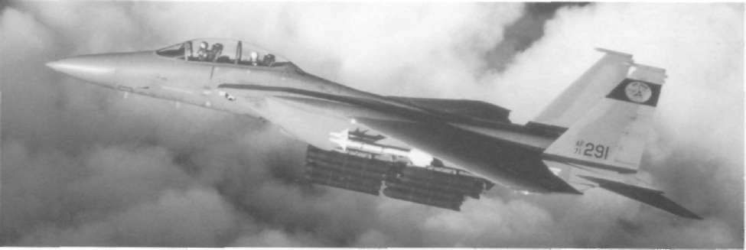
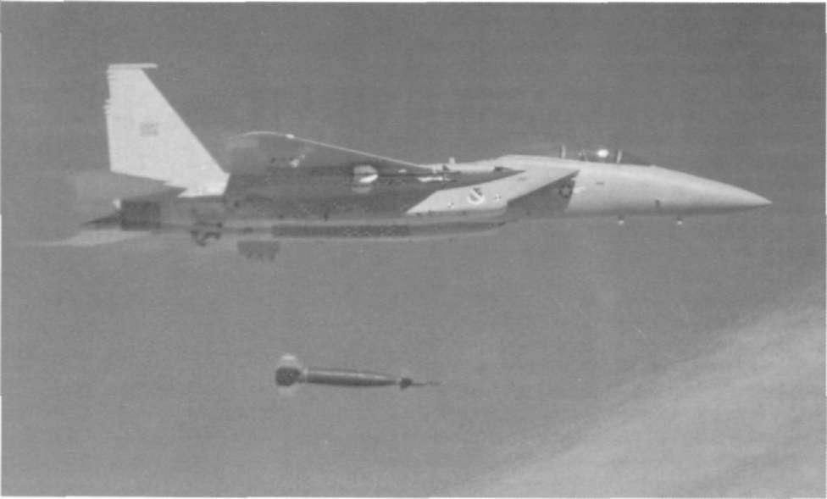
Above: One of eight full-scale development F-15A Eagles drops ratio remained high and the wing loading low by
a laser-guided bomb during trials conducted by the Air Force Flight Test Center from Edwards AFB.
contemporary standards, the F-15 still being a
sprightly performer, although 18 Mk-82s on the
Mk-82 "Snakeyes", weighing, at 5601b (254kg) each, a three MERs inevitably incurred a considerable drag total of 10,080lb (4,572kg). This, taking into account penalty. It was stated at the time that it could both the weight of the MERs, leaves plenty of margin
carry and release multiple stores at supersonic
between the maximum permitted load and the max-
speeds. Inn the store combinations that this applied imum feasible load. Training missions could also be to were not divulged. The weapons system was
flown with an SUU-20B/A gun pod on each point.
adjusted so that all relevant information could be Even with the maximum load, the thrust/weight
presented on the H U D and the pilot could thus carry out an attack without having to look inside the
Below: MCAIR's Advanced Fighter Capability Demonstrator, cockpit. Weapon selection switches were located near 71-0291, totes a particularly heavy weapons load during developmental work leading up to the F-15E model.
the pilot's left hand, so little movement was needed.
35
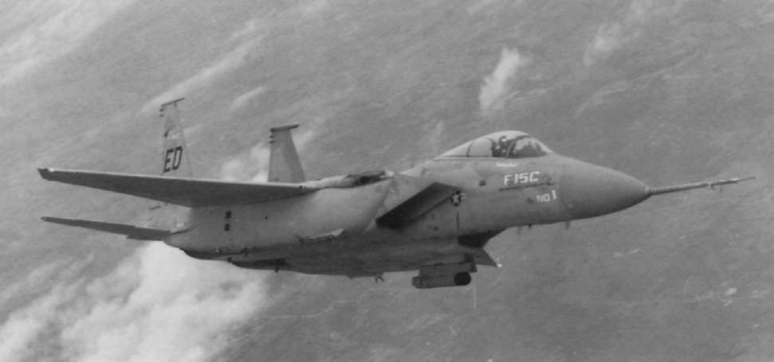
4
Improving the Breed
HAVING successfully developed what is Apart from improved avionics, the main feature of arguably the world's greatest air superior-the F-15C is greater internal fuel capacity. Extra ity fighter, the inevitable next step is to try
tanks were provided in the forward fuselage, the
to make it even better. This was the case with the wing inboard leading edges and behind the main
F-15A and F-15B. If the development phase is held wing tanks, these increasing the internal capacity back while waiting for new technology to emerge or f r o m 11,6351b (5,277kg) to 13,4551b (6,103kg). A if good ideas keep emerging and are incorporated
conformal tank was also developed to fit along the into the design as they arise, the end result is a paper fuselage sides beneath the wings to give an extra aeroplane that never makes the transition into actual 9,750lb (4,423kg) of fuel, this comparing well with hardware. The saying is "the better is the enemy of the three 600-gal external tanks which held 11,700lb the good" and the only way to make progress is to (5.307kg) of fuel. T h e slight shortfall is more than freeze the design at a certain stage and then build it.
compensated for by the fact that the conformal tanks This is not an admission that it could have been cause very little extra drag by comparison whilst the better from the start, but, rather, a practical three main hard points are now free to carry approach to getting an excellent fighter into service weapons. These conformal tanks can also be equip-when it is needed. Put simply, a good fighter in ped with sensors such as infra-red seekers, ECM
service today is of far more value than an even better equipment, laser designators and reconnaissance
one that is due to enter service in two years time. In cameras. As a result, they are known as Fuel And
all, close to 450 F-15As and F-15Bs were produced at Sensor Tactical (FAST) packs.
a ratio of roughly six single-seaters to every two-seater before the factory line switched to the next Below: Displaying the code of the 6512th Test Squadron at models, the F-15C and F-15D, in 1978.
Edwards AFB, 78-0468 was the first F-15C to be produced by McDonnell Douglas and made its debut in 1978.
36
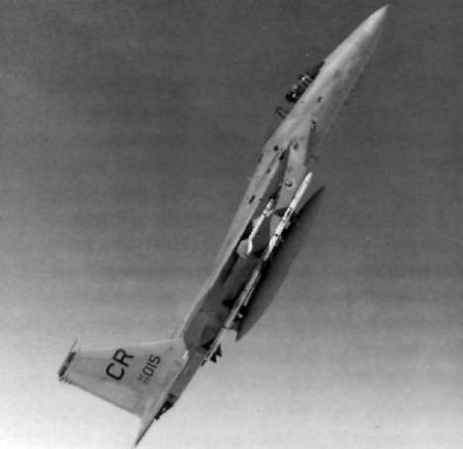
The extra internal fuel increases the F-15C's rammes (MSIPs) were announced for all Eagles, radius of action and combat endurance, while the
Stage I covering the F-15A/B and Stage II the
FAST pack, which can be fitted or removed in just 15
F-15C/D. Both MSIP initiatives involved improving minutes, increases them even more. With FAST avionic and weapons systems by upgrading the mem-packs plus three 600-gal drop tanks, the F-15C/D can ory system of the APG-63 while also trebling its speed make transatlantic flights without recourse to in-of processing to some 1.4 million operations per
flight refuelling. While the FAST pack is described as second.
having marginal impact on the drag factor, it does, of course, add extra weight, which reduces the thrust/
Revised cockpit instruments
weight ratio and increases the wing loading. This.
although it has not been officially quantified, must The armament control panel in the cockpit is to be inevitably result in a slight reduction in performance, replaced by a multi-purpose colour V D U , while particularly in the areas of acceleration and rate of making it programmable will provide for the car-climb, although the effect on t u r n capability should riage of future weapons such as A M R A A M . All that be marginal. The added fuel load led, however, to will then be needed is a software change to accommo-higher take-off gross weights and potentially higher date the new weaponry as and when it becomes
landing weights, which required a stronger under-
available.
carriage as well as better brakes, wheels and tyres.
In the event, MSIP I was left in abeyance while
This feature is the only external difference between MSIP II was given the go-ahead in February 1983,
the F-15A/B and the F-15C/D which are otherwise
the first MSIP II F-15C, serial number 84-001, being identical from the outside when con formal fuel tanks rolled out on June 20, 1985. MSIP will eventually are not carried.
allow better radar threat warning systems, improved communications systems and, potentially most signi-Enhanced radar capability
ficant of all, provision for the Joint Tactical Information Distribution System (JTIDS). Tis system prom-The avionics improvements on the F-15C/D main-
ises a quantum leap in fighter effectiveness, by
ly concern the radar. A programmable signal proces-enabling data to be transmitted automatically and sor has been fitted which considerably expands the securely between aircraft, the E-3 Sentry AWACS
capability of the APG-63 by controlling the modes Below: After equipping the Kadena-based 18th TFW in 1979, through software rather than circuitry. This permit-European deployment of the improved F-15C model began with ted greater resistance to EGM and, together with a the 32nd TFS at Soesterberg, Holland.
higher capacity computer, allowed for new radar
modes. For instance, a raid assessment mode was
added which could resolve the mass returns f r o m aircraft flying in very close formation in to individual returns at ranges of up to 40nm (74km), while
improved radar symbolism and a track-while-scan
mode was also developed. At a later date, a ground mapping mode, with Doppler beam sharpening, was
added, using synthetic aperture techniques. Nevertheless, the cockpit remained almost identical; the fuel gauges had been expanded to show greater
quantities, but little else had changed.
The first aircraft to fly with the conformal fuel tanks had been F-15B 71-0291 on July 27, 1974. The first F-15C. 78-0468, flew on February 27, 1979,
followed by the first two-seat F-15D on June 19 of the same year. Even then, nothing stood still for long with the result that Multi-Stage Improvement Prog-37
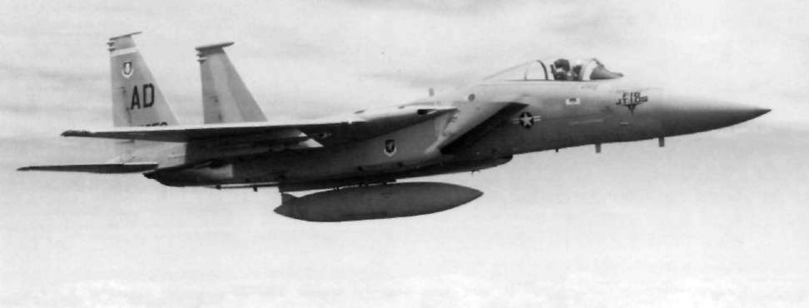
and the ground defence environment, thus increas-
40,000ft (9,150-12,200m), the EMD-powered F-15
ing the pilot's situational awareness many times over.
reached Mach 1.15, while it also accelerated from The final change between the F-15A/B and the Mach 0.8 to Mach 2 some 41 per cent faster than the F-15C/D has been fitment of the ACES II ejection
standard aircraft. It also demonstrated better dura-seat, which has supplanted that originally installed.
bility, carefree handling and superior air start capa-If the Eagle can be said to have a weak point, it lies bility. The -220, which has a maximum augmented
in the engine. The F100-PW-100—delivering appro-
thrust rating of nearly 28,000lb (12,700kg) will be ximately 15,000lb (6,804kg) of thrust in military installed in Eagles from 1986 onwards but no official power and 25,000lb (11,340kg) using full afterbur-performance figures are as yet available for this ner augmentation—suffered initially from stall version.
stagnation and was not the most durable of engines.
From the time that air-to-ground weapons were
As noted earlier, it was pushing the state of the art first hung on 71-0291, the USAF has shown an ever pretty hard and both problems have been largely
increasing interest in the attack capabilities of the overcome with the result that the F100 is now much F-15. The outcome was the F-15AFCD (Advanced
more reliable. Nevertheless, the F-15, following the Fighter Capability Demonstrator), referred to by
development path of virtually every other fighter in M C A I R as Strike Eagle. Later still, it became the history, has suffered f r o m weight growth and does F-15DRF (Dual Role Fighter) which, further de-need extra thrust if it is to recover its former vigour.
veloped, has been ordered as the F-15E. Due to enter service in 1988, 392 examples of the F-15E are to be Improving the engine
purchased. Both the AFCD and the DRF were
represented by 71-0291 which was specially adapted Some idea of the problem can be gained when it is for these roles.
appreciated that the maximum possible gross take-
Additional air-to-ground weapon carriage was ac-
o f f weight is now a colossal 75,0001b (34,020kg), this quired by the development of "tangential carriage"
having been demonstrated at Edwards AFB in along the corners of the FAST packs, which ren-November 1982. P & W has, however, been working dered the Sparrow stations unusable. Offensive capa-on engine improvements and these have led to the
bility was to be retained with Sidewinder on the wing F100-PW-220 version. Part of the improvement pylons and, later, when A M R A A M enters service, came f r o m an A i r Force-sponsored programme to this missile will also be carried under the wings.
produce higher thrust, and the F100 E M D (Engine Tangential carriage offers heavy load-carrying ability Model Derivative) was tested in a NASA F-15, serial with a lesser drag penalty than MERs. Maximum
number 71-0287, in the summer of 1983, the results being quite spectacular.
Below: Eagle capability has been further enhanced by the Joint Tactical Information Distribution System (JTIDS), which will Using military power, at altitudes between 30,000-greatly boost "pilot awareness" in combat.
38
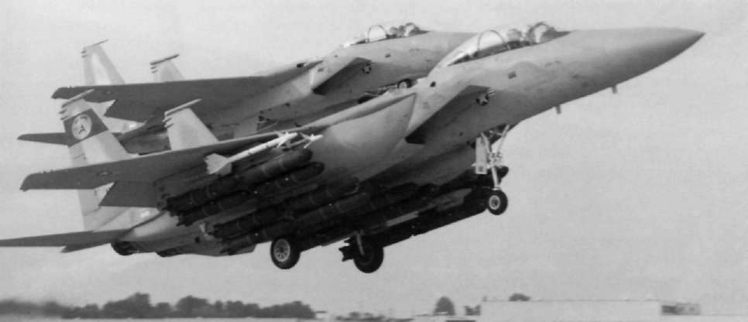
loads could be three Mk-83 and three Mk-84 low-
Above: Tangential carriage greatly increases Eagle payload capability. Here, MCAIR's demonstrator gets airborne with four drag or "smart" bombs along each side. Tangential AIM-9s and 22 Rockeye Cluster Bomb Units.
carriage can also be utilised by the F-15C/D but this model lacks the night and bad weather penetration of supplementing the F-111 in the night and adverse capability which will be a feature of the F-15E.
weather deep interdiction role. Installation of "Pave Pack" has been considered, this system comprising a
"Missionized" rear cockpit
pod containing laser spot designators and infra-red trackers, but the final fit is expected to be a L A N -
The greater single difference between the F-15E
PIRN pod to supplement the SAR radar mode.
and earlier models concerns the fact that it is opti-Weapons fit will depend on the specific mission, but mised for the strike role, with advanced avionics and will be more likely to consist of "smart" weapons a "missionized" rear cockpit for a Weapons System rather than " i r o n " bombs, for overflying a heavily Officer (WSO). Avionics and sensors include the defended target these days can only be described as APG-70 radar—a development of the present APG-
"sporty".
63—advanced nav/attack systems pre-programmed
by inserting a tape cassette containing mission data; Strike Eagle weapons options
Flir, and either a terrain-following or terrain-
avoidance system, the choice of which remains open Previous models of the F-15 seldom, if ever, utilise at present. The front cockpit appears to be consider-the outboard wing hardpoints, since these are severe-ably more modern than that of previous models, with ly weight limited, but the F-15E will almost certainly a wide-angle H U D and a moving map display but it is carry such items as the Westinghouse A N / A L Q -
the rear cockpit where the greatest changes are
119(V) jamming pod plus possibly a single
apparent for there are no flight controls. Instead, A M R A A M or the AGM-88A H a r m (High-speed four VDUs stretch f r o m wall to wall across the top of Anti-Radiation Missile). Other weapons compatible the instrument panel, all being multi-purpose and with the F-15E will include the AGM-84A Harpoon
managed by two hand controllers. The WSO can
anti-shipping missile and three variants of the A G M -
monitor aircraft systems, weapon status and enemy 65 Maverick, using infra-red, laser and electro-defences while using the T S D (Tactical Situation optical guidance. T h e French Durandal runway-Display) and the SAR display which provides almost busting bomb has been checked out and there can be photographic quality imagery to assist in detection of no doubt that tactical nuclear weapons may also be carried.
targets through smoke, haze or adverse weather.
The F-15E is officially described as being capable A close support weapon that can be carried is the 39
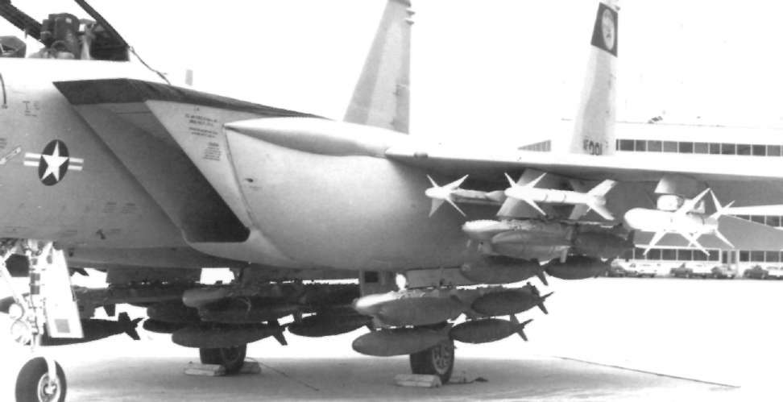
GFPOD 30 gun pod, which can be installed on both
Above: This close-up of the stores stations of the dual-role fighter demonstrator shows it to be carrying conventional "iron"
inboard wing hardpoints and the centre-line stores bombs plus AIM-9L and AGM-88A missiles.
station. This is a 30mm four-barrel GE430 cannon, mounted in a pod which contains 350 rounds of
bad-weather mission. At heights of just 200ft (61m) depleted uranium-tipped G A U - 8 ammunition as de-or even lower, turbulence is severe and the ability of veloped for the A-10. Rate of fire is 2,400 rounds per the aeroplane to fly the mission effectively for ex-minute and the effective range exceeds 7,000ft tended periods—a short time is not too bad but after (2,133m). Lethal against all lightly-armoured vehicles that crew efficiency suffers—depends on what is
and main tanks, it is also effective against dug-in known as its gust response, which is basically the way infantry and its main advantage over stand-off it copes with up and down-draughts.
weapons such as Maverick is that it does not need several seconds of level flight while the missile ac-Poor gust response
quires the target, but can be fired immediately after rolling out of a turn. Cheap and effective, it is not Good gust response is achieved by a combination
vulnerable to countermeasures, but, having said that, of high wing loading and low aspect ratio, which is it is difficult to envisage a tactical situation where it why many dedicated attack aircraft, like the F-111, would be viable to pit a multi-million dollar F-15 have been designed with variable-sweep wings. The against even a mass of relatively low-cost targets such F-15's moderate aspect ratio of 3, combined with
as tanks if they were supported by modern counter-what will be, by attack aircraft standards, a compara-air systems.
tively light wing loading, will not bestow a smooth ride at the low levels needed to survive. Indeed, one Survival requirements
report has referred to the low level penetration
altitude of the F-15F as being 500ft (152m), but this, One must have doubts about the efficacy of the although it would alleviate the gust problem, is far F-15E as a supplement to the F-111. It is generally too high for safety.
recognised that in order to survive against a modern The F-15F will be powered by either of two
defensive network and penetrate to the target, trans-engines. T h e F100-PW-220 will alternate with
onic speed at ultra-low altitude is needed, with a General Electric's new F110 of about the same rating.
dedicated terrain-following radar for the night and A common engine bay is under development while.
40
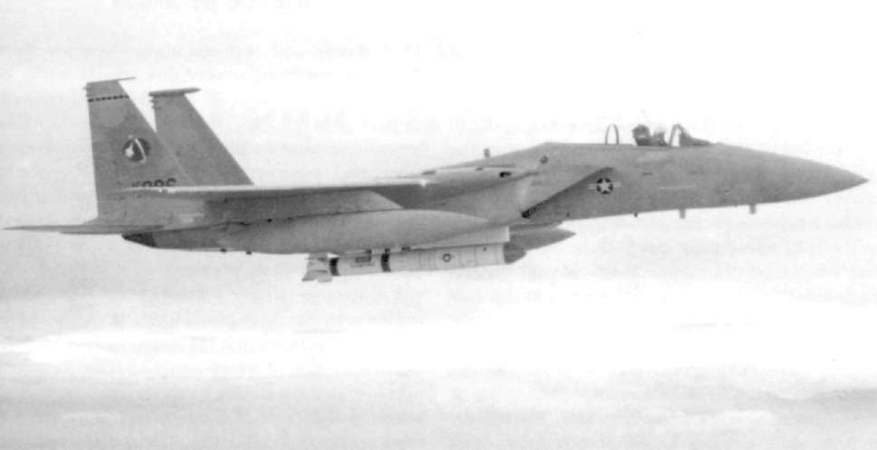
Above: One new role due to be undertaken by the Eagle is that of Boeing's AGM-69 Short-Range Attack Missile, while
"satellite-busting". Here, Vought's ASAT weapon undergoes captive flight trials on an F-15A.
the second is powered by an Altair I I I rocket motor.
A large missile, it is 17.81ft (5.43m) long and weighs in the future, growth versions of both engines are around 2,700lb (1,225kg). Carriage is on the centre-planned and these should eventually provide au-
line station of an F-15 which uses a special launch gmented thrust ratings of the order of 30,000lb pylon with a back-up battery, a communications link (13,608kg).
and a microprocessor. Captive flight trials were
The demonstrator for the F-15E programme, accomplished in 1983 and the first launch took place 71-0291, has been flown in at least three different on January 2 1 , 1984, at least two F-15s being in-colour schemes d u r i n g the trials period, these com-volved in the trials (76-0086 and 77-0084).
prising air superiority grey, a two-tone sandy desert camouflage and the two-tone dark green livery
ASAT downs a satellite
known as "European One", which is sported by the A-10A Thunderbolt I I .
Delays in getting an instrumented target into space Several other missions have been mooted for the
led to the first "hot" test being made again a scientific F-15 of which perhaps the most spectacular is the satellite on September 15, 1985. The successful des-destruction of communications satellites. Dealing truction of this satellite caused a bit of an uproar at with targets in space poses many peculiar problems, the time, as it was apparently still transmitting data not least of which is that, in a vacuum, the blast of an back to earth, despite being near the end of its useful exploding warhead attenuates very quickly, being life. While not officially confirmed, it seems probable more or less confined to the immediate area of the that a live satellite was needed in order to precisely gases expanding f r o m the explosion. Shrapnel effect establish destruction.
is dependant on enough pieces of sufficient size
A S A T launch obviously needs precision flying of a travelling in the right direction with enough velocity.
high order, the F-15 essentially being a third-stage In the event, it was decided to dispense with a booster for the missile, and it thus has to reach high warhead and go for a direct hit.
altitude. Normal procedure will probably entail
A contract was duly awarded to the Vought Cor-
accelerating to maximum speed, then zoom climbing poration in 1979 to develop an anti-satellite (ASAT) to 80,000ft (24,400m) when the missile will be laun-system. A two-stage missile, the first stage is based on ched and it is reasonable to suppose that the position 41
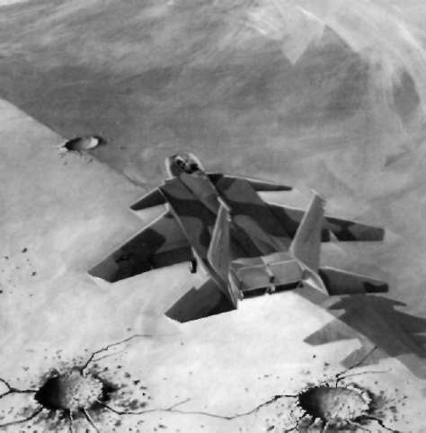
and timing of the F-15 at launch are critical, while the Improved performance
launch angle may well also be.
Another role suggested for the F-15 is that of The canards and vectored thrust between them
"Wild Weasel" defence suppression. The develop-should permit flight at very slow speeds, while, by ment aircraft for this scheme is, once again, 71-0291.
themselves, the canards will unload the horizontal tail which has been fitted out with a chin pod similar to surfaces, thus reducing trim drag. The results will be that carried by the F-4G Phantom, this housing the better instantaneous turning performance, greater AN/APR-38 radar homing and warning system re-range and improved acceleration. The vectoring
ceivers and antennae. S A M suppression is mainly a nozzles may also be used to improve turning per-job for a two-seat aircraft and adoption of the F-15F
formance and, at low speeds, will allow the F-15 to as the dual role fighter may well be an influential "swap ends" very rapidly to offer some head-on factor in the possible acquisition of a " W i l d Weasel"
discouragement to a pursuer.
Eagle (the Weagle?). Weaponry carried in this role A fly-by-wire system will be incorporated which
would include the AGM-88A H a r m , although Shrike will integrate the functions of the canards, the ortho-and Standard-ARM missiles could also be used.
dox control surfaces and the vectoring nozzles, indi-At present, USAF tactical reconnaissance is carried vidual operation of which would increase the pilots out by the ageing RF-4C Phantom. A canoe-shaped
workload to unacceptable levels.
reconnaissance pod similar to that carried by
Yet another area of development is to upgrade
reconnaissance-dedicated USN Tomcats has been existing sensors to allow the F-15 to make precision proposed as a conformal fit on the centre-line station approaches and landings without recourse to exter-of the F-15 but it seems likely that special interface nal aids, which are always liable to suffer battle equipment would have to be built in to the Eagle, a damage. T h e improved sensors are intended to
few examples of which may eventually be modified.
make operations autonomous insofar as the recovery phase is concerned.
Finally, the S T O L Eagle is to have a new undercar-A STOL derivative
riage able to cope with rough field operation and no-flare landings.
The next generation F-15 may well be a very
different looking bird indeed. At present, the Fagle Below: Expected to fly for the first time in about 1988, the STOL
Eagle will nave canard foreplanes and thrust vectoring to reduce is tied to long stretches of concrete runway, or, at a field length requirements.
pinch, motorway. They can get o f f the ground in a very short distance, but the landing r u n , with no braking parachute and in the wet, is still considerable. Meanwhile, a new generation of fighters capable of outfighting the Fagle has been planned and this has resulted in a requirement for a S T O L (Short Fake-off and Landing) and manoeuvring technology
demonstrator for which M C A I R has received a
contract. The USAF specification stipulates that the S T O L Eagle must be able to operate at normal
combat weight from a 1,500ft (457m) strip of runway at night, in poor visibility and in a cross-wind in rainy conditions.
T h e S T O L Fagle, which is not scheduled to fly bet ore 1988, will feature two dimensional vectored thrust nozzles, plus thrust-reversing for rapid braking and will also have canard lorcplancs with a
pronounced dihedral fitted to the sides of the
intakes.
42
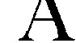
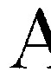
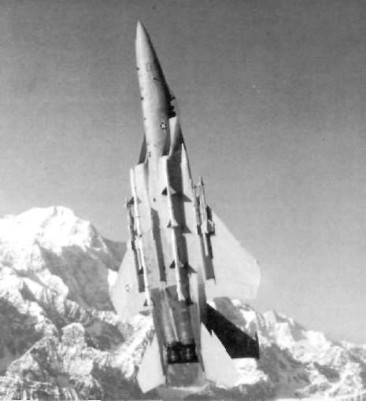
5
Eagle in Service
N Y O N E W H O has seen the Eagle perform
ron to be equipped with the type was the 555th
a " V i k i n g " departure is unlikely to forget it Tactical Fighter Training Squadron (TFTS), the
in a hurry! The rib cage-vibrating noise of
famous "Triple Nickel" outfit which had ended the two F100s in full' burner; the big fighter accelerating Vietnam War as the top scoring unit, claiming 39
rapidly down the runway, lifting off, then pulling MiGs destroyed, 24 of them MiG-21s. The initial
vertically up and still accelerating until out of sight, is colour scheme was air superiority blue but this soon an impressive experience. The F-15 is very well liked switched to two-tone compass grey. T h e n in 1977, six by the pilots who fly it. As a flying machine it is easy Fagles at Nellis A F B in Nevada took part in the joint to handle and very forgiving of errors. It is almost USAF/USN A I M V A L / A C E V A L (missile and com-impossible to spin; on the rare occasions that spins bat) evaluation. Assigned to the 57th Fighter
have occurred, it has usually been due to an out-of-Weapons Wing, they were given a two-tone grey
balance condition arising from improper fuel trans-countershading paint j o b , sometimes erroneously fer between tanks. It exhibits a certain sensitivity on referred to as aspect deception camouflage. There the controls, particularly in pitch, but this just needs has been some aspect deception paintwork applied to practice to master. The turn capability, acceleration F-15s but this has been little more than a dummy
and rate of climb are all much appreciated and I canopy on the underside in matt black with irregular have yet to meet an Eagle driver who wants to Hy
splodges of gloss black to simulate highlights.
anything else. On the other hand, the workload
caused by the systems is high; H O T A S calls for a Below: Carrying a full array of AIM-7 Sparrow and AIM-9
Sidewinder air-to-air missiles, an F-15A of the 43rd TFS at great deal of manual dexterity to get the best out of it Elmendorf AFB, Alaska, thrusts skywards.
and plenty of flying time is needed if pilots are to stay sharp.
Early deployment
In the early days of European deployment,
Aggressor pilot Capt. Bill Jenkins commented:
"Sometimes they are so busy with all the magic in the cockpit that we can sneak up and fly wing on them before they notice." That, however, was many years ago; the F-15 is well established now, its capabilities are well known and its pilots are highly polished performers.
The first operational F-15 was a two-seat trainer, serial number 73-0108, and it was delivered to Luke AFB, Arizona on November 14, 1974. T h e occasion was marked by a ceremony attended by President
Ford and the TF-15A was marked " T A G 1" on the nose. The unit which received it was the 58th Tactical Fighter Training W i n g ( T F T W ) and the first squad-43
Countershading—utilising a splinter pattern re-miniscent of the Luftwaffe d u r i n g World War 2—
F-15s SERVING US AIR FORCE UNITS
was simply an attempt to render the big fighters
O P E R A T I O N A L A N D T R A I N I N G U N I T S
Unit
Squadrons Base
N o t e s
rather less visible by darkening areas which would 1st TFW
27 TFS Langley, Va. F - I 5 A from J a n 1970.
normally be highlighted and lightening other areas.
71 T F S
F-15C f r o m D e c 1981.
9 4 T F S
Tail c o d e FF. 12th A F ,
It failed because it assumed that fighters always fly T A G .
wings level at high noon and in low sun conditions, 18th T F W
12 T F S
K a d e n a ,
F-15C 1979 o n w a r d .
44 TS O k i n a w a
Tail c o d e ZZ. 5 t h A F ,
such as at dawn or sunset, it was actually counterpro-6 7 T F S
P A G A F .
21st TFW
4 3 T F S
E l m e n d o r f ,
F-15A from M a r c h
ductive.
Ak.
1982. Tail c o d e AK.
The first fully operational unit was, rather approp-Alaskan An
G o m m a n d .
riately, the 1st T F W at Langley, Virginia, which 32 T F S
S o e s t e r b e r g , F - 1 5 A l a t e 1978, F-H o l l a n d .
15G late s u m m e r
received its first Eagle in January 1976, the aircraft 1980.
concerned (74-0083) being named 'Peninsula Pat-
Tail c o d e C R . U S A F E ,
33rd T F W
5 8 T F S
Eglin, Fl.
F-15A early 1979. F-
riot". The first two squadrons of this wing were 5 9 T F S
1 5 G / M S I P
declared mission-ready by the end of the year, the 66 TFS
c o m m e n c e d a u t u m n
1985. Tail c o d e KG.
next unit to equip being the 36th T F W at Bitburg, 9th A F , T A G .
36th T F W
22 T F S
B i t b u r g ,
F-15A from Dec 1976,
West Germany. Conversion was, in fact, undertaken 5 3 FFS W . G e r m a n y F-15C f r o m A u g 1980.
at Langley and the first two Eagles—destined for
5 2 5 FFS
Tail c o d e B T 17th
AF,
"hands-on" maintenance training—reached Ger-U S A F E .
49th T FW
7 FFS H o l l o m a n ,
F-15A from Oct 1977.
many on January 5, 1977. From then on, conversion 8 T F S
NM
Tail c o d e H O . T A G .
on to the type proceeded apace as more and more
9 T F S
57th F W W
422 FFS Nellis, Nv.
Tail c o d e W A ,
aircraft became available.
F-15 FWS
formerly 5 7 F W W / 4 3 3
FWS. T A G .
4 0 5 t h TTW
426 TFTS Luke, Az.
Originally 5 8 t h T T W ,
Eagles at Kadena
461 TFTS
tail c o d e LA. 12th A F ,
5 5 0 T F T S
T A C .
5 5 5 T F T S
The first F-15Cs went to the 18th LEW at Kadena,
A I R D E F E N C E ( A D T A C ) U N I T S
Okinawa, d u r i n g 1979, while the new models duly 5th FI S
Minot. ND
F-15A from J u n e
1985.
appeared in Europe when the 32nd TFS at Soester-
48th FIS
Langley, Va First A D T A C unit
with F-15A from
berg in Holland traded in its F-15As and F-15Bs.
August 1981.
Tactical A i r Command had had first call on the 57th FIS
Keflavik,
ADTAC u n i t s do not
Iceland.
normally c a r r y tail
new fighter, but units dedicated to the air defence of c o d e s , but t h e 5 7 t h is
an e x c e p t i o n .
the North American continent eventually began to
e m p l o y i n g IS. It was
acquire Eagles in exchange for their antiquated
previously the only
A D T A C unit with F-
F-106s, a process which began with the 48th Fighter 4Es a n d did not carry a
tail c o d e on t h e m . First
Interceptor Squadron al Langley. Still later, in June aircraft received late
1985, the first A i r National Guard unit—Louisiana's 1985.
3 1 8 t h FIS
M c C h o r d . W a .
122nd Tactical Fighter Squadron—started to equip
3 2 5 t h T T W
1 TFTS
Tyndall, Fl
Tail c o d e T Y .
with the type. T h e accompanying box contains what 2 TFTS
AIR N A T I O N A L G U A R D
is believed to be a complete list of all USAF units now 122 T F S , L o u i s i a n a ANG from J une 1985. New Orleans. La.
operating the Eagle.
T E S T U N I T S
6 5 1 2 TS
E d w a r d s , C a . T a i l c o d e E D .
The Warner-Robins A i r Logistics Center 4485 TS
Eglin, Fl.
Tail c o d e OT
(WRALC) at Robins A F B , Georgia also has one F-15
3 2 4 6
T W / T A W C Eglin. FI.
Tail c o d e A D .
for miscellaneous duties in connection with its function as the primary Eagle rework facility. Originally carrying the unofficial tail code WR—an acronym of the Luftwaffe and the Royal A i r Force. Many with Warner-Robins—this aircraft is now coded RG, this limited budgets rejected it on cost grounds while signifying Robins, Georgia.
others, such as the Royal A i r Force, needed a highly Many nations and services have evaluated the specialised aircraft for a specialised task. Outside of F-15, these including the Canadian Armed Forces. the United States, only three nations operate the 44
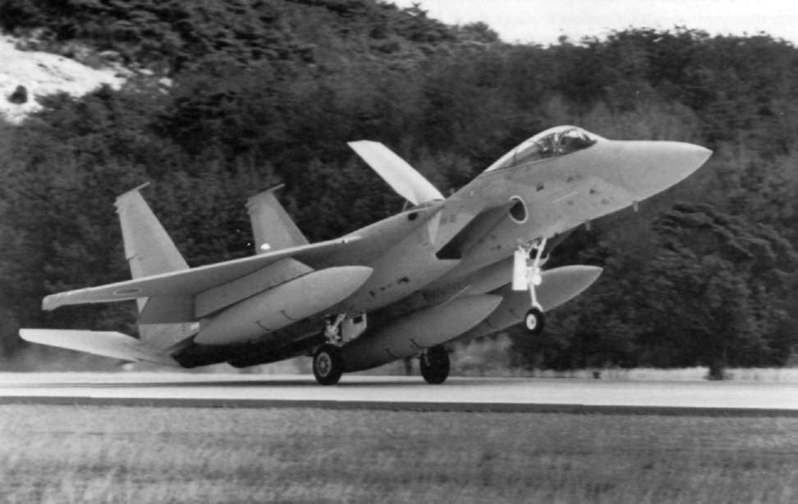
Eagle, export versions lacking certain sensitive and JAPANESE AIR SELF-DEFENCE
highly classified equipment in their ECM package.
FORCE UNITS
The first nation to operate the Eagle was Israel, Hikotai
Date formed Parent unit
Base
which received its first aircraft on December 10, (Squadron)
(Kokudan)
1970, under a programme called "Peace Fox". A 202
December 1982 5
Nyutabaru
203
April 1083 2
Cnitose
total of 40 aircraft was delivered quite quickly and 204
April 1984 7
Hyakuri
two squadrons were equipped with the F-15A and
207
April 1985 2
Cnitose
305
April 1986 7
Hvakuri
F-15B.
301
1987 5
Nyutabaru
Israeli security gives little away, but it is almost Programme name is "Peace Eagle" and normal squadron strength is 18 aircraft.
certain thai the first Eagle unit was No. 133 Squadron. Further aircraft were ordered, but deliveries were delayed as a result of Israel's excursion into the the Rinji (temporary) F-15 Hikotai at Nyutabaru.
Lebanon. However, latest information states that
This was redesignated as the 202 Hikotai in Decem-three aircraft were handed over in May 1985. in-
ber 1982 and presently serves as the JASDF conver-creasing the total received to 50. Of these, it is known sion unit for the type. A list of" present and future that one E-15B was damaged beyond repair in a JASDF Eagle units is given in the accompanying box.
The Royal Saudi A i r Force was next to receive the mid-air collision with a Skyhawk while on a training Eagle, its aircraft being delivered from 1982 onwards mission.
and the BAC Lightning squadrons were duly re-
The Japanese A i r Self-Defence Force (JASDF) was equipped with the type. The first Eagle unit in Saudi next to acquire the type, it being redesignated F-15J
service is believed to be No. 13 Squadron and it is and the subject of a licence production agreement known that it now operates from Dhahran. Khamis
between McDonnell Douglas and Mitsubishi. T h e
overall requirement is for 190 aircraft and the first Below: The second overseas customer to buy the Eagle was the Japanese Eagle arrived at Gifu in March 1981, to j o i n JASDF which requires about 190 aircraft, most of which will be the A i r Proving Wing. The first operational unit was built under licence by Mitsubishi.
45
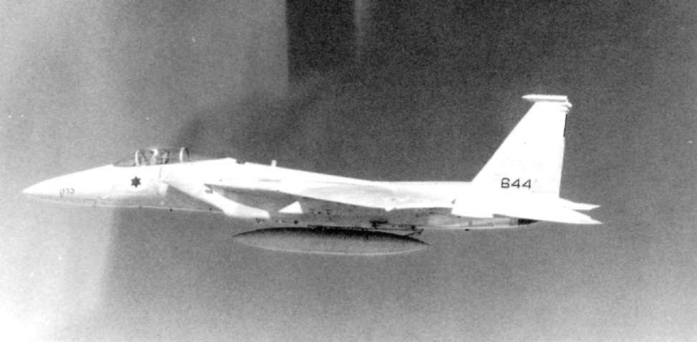
Mushayt and Taif. Some 62 aircraft were procured
combat in the early- 1980s, an Eagle driver launched under the "Peace Sun" programme, this figure in-himself f r o m 20,000ft (6,100m) at a target aircraft at cluding two F-15C attrition reserves initially held in 13.000ft (3,950m). At an airspeed of 500kts (927km/
the USA. At least one Saudi aire raft has been lost in a hr), he let his nose get too low and commenced a
landing accident and further procurement appears hard pull-up, reaching 9g and recovering to level to have been ruled out by the recent large order for flight at 5,000ft (1,500m). Inevitably, his head was the Tornado and by the "Camp David" peace agree-forced down against his chest and he ended the flight ment which stipulated that no more than 60 F-15s with a compression fracture of the seventh vertebra may be based in Saudi Arabia.
in his neck. Clear evidence that there are times when The combat capability of the F-15 was extensively the sparkling performance of the Eagle must be
tested in the United States in the mid-1970s. Aircraft treated with care.
from Eglin AFB successfully intercepted drones
Hying at Mach 2.7 at 70,000ft (21,300m) while, later.
Combat action
over the Navy test range at China Lake, California, a succession of one versus one combats were simulated The Eagle has also seen combat action with two air against different types, the results being outstanding.
forces, namely those of Israel and Saudi Arabia. Of Victories were recorded in four combats against
the two, the Israeli machines have seen by far the the A-37, 46 engagements with the T-38, simulating bulk of the action.
the MiG-21, 29 engagements against F-5Es also
Blooding of the Eagle came on June 27, 1979
simulating the M i G - 2 1 , 17 engagements against the when a mixed force of F-15s and Kfirs covered a
A-4 simulating the MiG-17, 13 engagements against strike force attacking terrorist bases in Southern the F-106 simulating the MiG-23 and no less than 67
Lebanon. Between eight and a dozen Syrian MiG-21s engagements against the Phantom, also simulating died to intervene, were detected by a supporting-the MiG-23. There were just two ties—both against Israeli Hawkeye and were thoroughly bounced by
the Phantom—where neither aircraft "fired".
the escorts, losing five of their number; four of them The acceleration and turning capability combined
falling victim to Eagles. Intermittent clashes occurred with the superb weapons system to make the F-15 a subsequently and the Eagle score gradually built up.
world-beater. It is stressed to take plus 9g and minus 3g loadings, which is a great asset in combat, but Below: As far as combat is concerned, Israel's Defence Force/Air Force leads the way, IDF/AF F-15s having already sometimes not so good in training. In one practice accounted for more than 50 assorted MiGs.
16
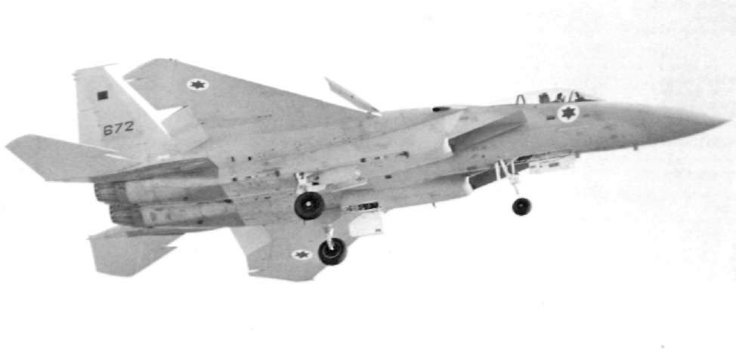
was. quite literally, a disaster for them; over 8O
ISRAELI EAGLE KILLS
aircraft being lost in air combat at no cost to the Type
Total
Weapons used where known
Israelis. As would be expected, the F-15 performed MiG-21
l51/2*
6 with Sparrow
41/2 with Sidewinder or Shafrir
excellently, accounting for no fewer than 42 Syrian 2 with cannon lire
5 unknown (*denotes 2 probables)
aircraft. Full details of Eagle victories in Israeli MiG-23
3
Unknown
service are not available, but the table details data MiG-25
3
All Sparrow.
"MiGs"
34
Unknown. Believed to be mainly
that had been made available to August 3 1 , 1982, MiG-23s and Su-22s, but possibly
when yet another "Foxbat" fell to an Eagle.
included some Su-I7s.
Helicopters
1
Probably cannon fire
The record of the F-15 in Israeli service—with a
kill/loss ratio of 56.5 to zero—has never been surpas-Then, on March 13, 1981, a "Foxbat" tried to sed in the history of air combat, but, even then, it was intercept an Israeli RF-4E and was clowned by a
not all over. On October 1, 1985, the Israeli A i r Sparrow fired from an escorting F-15. The Eagle
Force mounted a long-range strike against PLO
had at last triumphed over the aircraft which it had headquarters in Tunisia. Originally thought to have heen designed to match.
been carried out by F-16s escorted by F-15s, it is now The next Eagle victim was yet another "Foxbat", believed that only the F-15 was involved. T h e raid hit by a Sparrow on July 29, 1981, again while trying involved a round-trip of roughly 2,600nm
to intercept an RF-4E. Meanwhile, the F-16 strike on (4,800km), carrying 1,00011) (454kg) iron bombs, as the Iraqi nuclear reactor near Baghdad had been
well as some laser-guided weapons. Three in-flight flown the previous month and, while the F-16 was
refuellings were needed and support was also given rightly given the credit for bombing this target. F-15s by ECM aircraft.
provided the fighter escort.
The final air combat victories to date have, ironi-On June 6, 1982, Israel launched the "Peace for cally enough, been scored against earlier fighters Galilee" operation, namely the invasion of Southern produced by McDonnell Douglas. On June 5, 1984, a Lebanon. Over the next few days, a series of massive USAF E-3 AWACS on patrol over the Persian Gulf
dogfights took place above the Bekaa Valley as the detected two Iranian fighters approaching Saudi
Syrian A i r Force attempted to assert itself. The result Arabian airspace. T w o Saudi Eagles were vectored to the scene and launched Sparrows at the intruders, Below: Caught just before landing, F-15A No.672 typifies Israeli which proved to be F-4E Phantoms, both were
Eagles with regard to presentation of national markings. As usual, unit insignia has been censored.
knocked down.
47

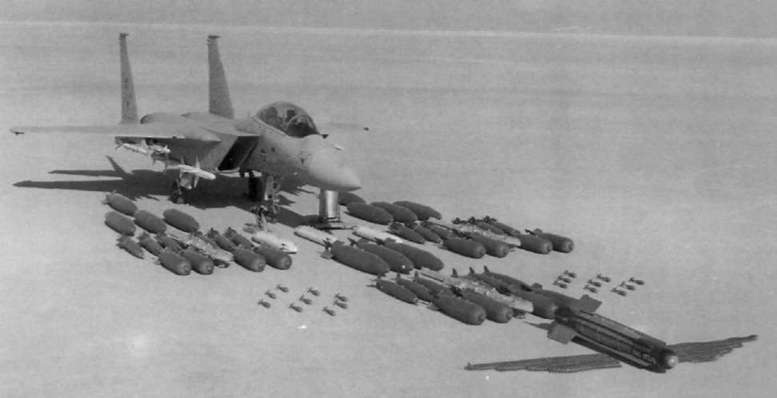
Above: Some idea of the multitude of weapons options available TF-15A test specimen at Edwards AFB in the early '70s. New to the Eagle can be gained from close study of this picture of a weapons and other stores can now be added to the display.
F-15 EAGLE WEIGHTS
Figures given are lb(kg) and arc approximate
F-15A
F-15B
F-15C
F-15D
F-15C with FAST pack
Empty
28.000 (12.700)
28,600 (12,973)
29,180 (13,236)
20.780 (13.508)
30,300 (13,699)
Takeoff in fighter
configuration, intl
41,500 (18,824)
42,300 (19,187)
14,500 (20,185)
45,300 (20,548)
55,270 (25,070)
fuel, 8 missiles
Max TOGW
56,500 (25,401)
56,500 (25,401)
68,000 (30,844)
68,000 (30,844)
68,000 (30,841)
Combat wt, 8 missiles
and 50% intl fuel
35,680 (16,184)
36,280 (16,457)
37.772 (17.133)
38,573 (17,496)
43,668 (19,808)
Internal Fuel
11,635 (5,277)
11,635 (5,277)
13,455 (6,103)
13,455 (6,103)
23,205 (10,526)
Fuel in FAST packs
N/A
N/A
9,750 (4,423)
9,750 (4,423)
N/A
Fuel carried externally
in three 600 US
gal tanks
11,700 (5,307)
11,700 (5,307)
11,700 (5,307)
11,700 (5,307)
11,700 (5,307)
Max weapon load
12,000 (5,513)
12,000 (5,543)
16,000 (7,258) or
18.000 (8.165) with tangential carr.
L O A D I N G S (all at combat weight)
Wing loading
(lb/fP-kg/m2)
59 (288)
60 (293)
62 (303)
63 (308)
72 (351)
Thrust loading
(lb/lb kg/kg)
1.40 (0.63)
1.38 (0.62)
1.32 (0.60)
1.30 (0.59)
1.15 (0.52)
Note: Little data is available on the F-15E except that a max TOGW of 81,0001b (36,742kg) is proposed.
D I M E N S I O N S ,
E N G I N E D E T A I L S
P E R F O R M A N C E
All models (A, B, C, D, & E) identical
Type Pratt & Whitney F100-PW-100
V max at altitude
Mac h 2.5 +
Length 63.75ft (19.43m)
Military thrusl 16,2001bs (7,348kg)
V max at sea level
Math 1.2
Wing span 42.81ft (13.05m)
Augmented thrusl 25,0001bs (11,340kg)
Initial climb rate
50,000 ft/min
Fin height 18.46ft ( 5 . 6 3 m )
Military sfc 0.681bs/lb (0.31 kg/kg)
(254m/sec)
Tail span 28.25ft ( 8 . 6 1 m )
Augmented sfc 2.551bs/lb (l.l6kg/kg)
Minimum control speed
100kts
Main gear track 9.03ft ( 2 . 7 5 m )
Length 15.92ft (4.85m)
(185km/hr)
Wing area 608ft2 (56.5m2)
Diameter 4.25ft (1.30m)
Unrefuelled duration
5.25 hours
Weight 2,855lbs (1,295kg)
(with conl formal tanks)
Refuelled duration
14.25 hours
Service ceiling (65,000ft (10.800m)
Absolute ceiling 100,000ft (30,480m)
Design loadings
+9g/-3g
Instantaneous turn
14.1 degrees/sec
Sustained turn 1 1.8 degrees per second
48

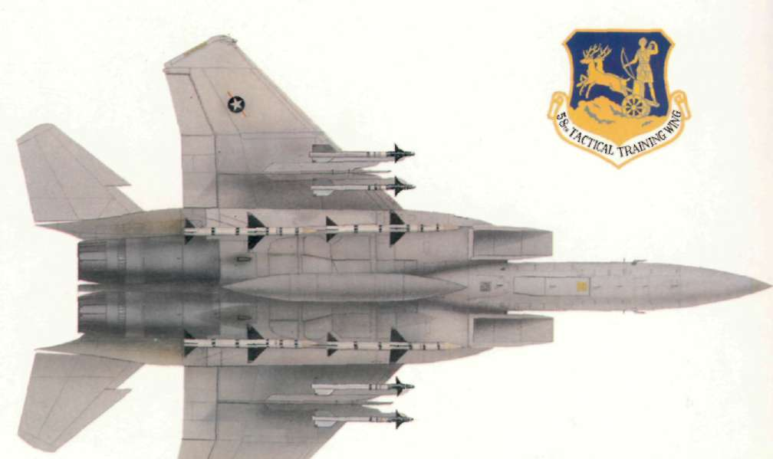
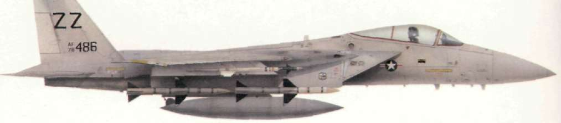


COMBAT AIRCRAFT SERIES
Presented in a compact format, the OSPREY C O M B A T
AIRCRAFT SERIES is a stimulating source of visual reference and detailed text on the world's leading warplanes. Each title features 48 pages (including 8 packed with spectacular full-colour artwork, plus colour photos). 30 black and white photos and comprehensive data tables.
1. McDonnell Douglas F-15 Eagle
2. McDonnell Douglas F/A-18 Hornet

